Acceptance tests   
Acme-Newspaper v1.0

|  |  |
| --- | --- |
| ****Development team**** | |
| **Identifier** | Group 88. |
| **Members** | Blanco Ferreira, Juan Miguel; Diment Rodríguez, Daniel; Guerrero Díaz, Alejandro; Jiménez Navarro, Manuel Jesús; López López, Luis Javier; Rodríguez Artacho, Antonio; |
| **Testing team** | |
| **Identifier** | Group 19 |
| **Members** |  |
| **Indexing data** | |
| **Test designers** | Blanco Ferreira, Juan Miguel; Guerrero Díaz, Alejandro; Jiménez Navarro, Manuel Jesús; López López, Luis Javier |
| **Testers** |  |
| **Notes** |  |

Table of contents

Use case 001 – Register as a user 4

Use case 002 – List and search newspapers 9

Use case 003 – Search for articles 13

Use case 004 – List and display user 18

Use case 005 – Create a newspaper as a user 21

Use case 006 – Publish a newspaper 25

Use case 007 – Write an article 27

Use case 008 – Post a chirp as user 31

Use case 009 – Follow or unfollow a user 34

Use case 010 – List users that a user follows 36

Use case 011 – List users who follow the logged user 38

Use case 012 – Display a stream with the chirps of the followed users 39

Use case 013 – Register as an agent 41

Use case 014 – Create advertisement 43

Use case 015 – List newspapers with an advertisement 47

Use case 016 – List newspapers without an advertisement 49

Use case 017 – Remove an article 51

Use case 018 – Remove an unappropriated newspaper 54

Use case 019 – Dashboard 57

Use case 020 – Manage a list of taboo words 60

Use case 021 – List the articles that contain taboo words 63

Use case 023 – List the newspapers that contain taboo words 66

Use case 024 – List advertisements containing taboo words in its title 69

Use case 025 – Remove an unappropriated advertisement 73

Use case 026 – Broadcast a message to the actors of the system 76

Use case 027 – Remove an unappropriated chirp 79

Use case 028 – List the chirps that contain taboo words 82

Use case 029 – Not authenticated list volumes and its newspapers 85

Use case 030 – Send message 88

Use case 031 – Register as a customer 99

Use case 032 – Subscribe newspapers as customer with credit card 104

Use case 033 – Change owns newspaper to public or private 108

Use case 034 – Subscribe volume as customer with credit card 111

Use case 035 – Create new volumes as user 116

Use case 036 – Create a follow up 119

Use case 037 – List created follow ups 123

Additional tests 125

# Use case 001 – Register as a user

Description

An unauthenticated user goes to the register view and fills the form, once the form is filled, he or she presses the register button.

Access

Main Menu > Register in the system > Register as user.

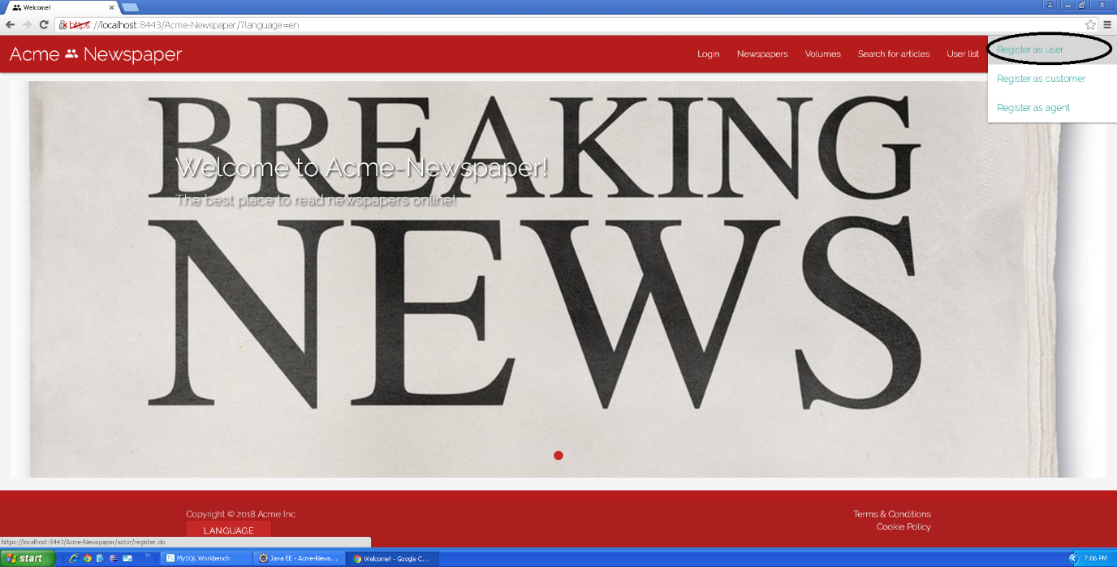

Tests

|  |  |
| --- | --- |
| **Test <#001>** | |
| **Description** | The form must be filled in with the following data: **Name:** ‘Jose’; **Surname:** ’Delgado García’; **Phone number:** ‘650879554’; **Postal address:** ‘123 Walk Street, USA’; **Email:** ’[josedega@us.es](mailto:josedega@us.es)’; **Birthdate:** ’16/04/1996’ **Username:** ‘josedega’; **Password:** ‘josedega’; **Confirm password:** ‘josedega’. You must also accept **Terms & Conditions**. |
| **Expected** | At the end of the use case, the system must redirect you to the main view. |
| **Outcome** |  |
| **Notes** |  |

|  |  |
| --- | --- |
| **Test <#002>** | |
| **Description** | The form must be blank, only the “I accept Terms & Conditions” box must be checked, otherwise the “Register” button will be inaccessible. |
| **Expected** | At the end of the use case, the system must redirect you to the same form, but each field must have its validation error. |
| **Outcome** |  |
| **Notes** |  |

|  |  |
| --- | --- |
| **Test <#003>** | |
| **Description** | Once you access the form, you must press the “Cancel” button. |
| **Expected** | You must be redirected to main view. |
| **Outcome** |  |
| **Notes** | In this test field content can be both filled or blank. |

|  |  |
| --- | --- |
| **Test <#004>** | |
| **Description** | The form must be filled in with the following data: **Name:** ‘<script>alarm('Hacked!'); </script>’; **Surname**: ’Delgado García’; **Phone number:** ‘650879554’; postal address: ‘123 Walk Street, USA’; **Email:** ’[josedega@us.es](mailto:josedega@us.es)’; **Birthdate:** ’16/04/1996’ **Username:** ‘josedega’; **Password:** ‘josedega’; **Confirm password:** ‘josedega’. You must also accept **Terms & Conditions**. |
| **Expected** | At the end of the use case, the system must redirect you to the register user form with an error message in “Name” field where you can read “Insecure HTML” |
| **Outcome** |  |
| **Notes** |  |

|  |  |
| --- | --- |
| **Test <#005>** | |
| **Description** | Before accessing the form, language must be set to “Spanish”, after this, the form must be filled in with the following data: **Nombre:** ‘Jose’; **Apellidos:** ’Delgado García’; **Número de teléfono:** ‘650879554’; **Dirección:** ‘123 Walk Street, USA’; **Correo electrónico:** ’[josedega@us.es](mailto:josedega@us.es)’; **Fecha de nacimiento:** ’16/04/1996’ **Nombre de usuario:** ‘josedega’; **Contraseña:** ‘josedega’; **Confirmación de contraseña:** ‘josedega’. You must also accept **Términos y Condiciones**. |
| **Expected** | At the end of the use case, the system must redirect you to the main view. |
| **Outcome** |  |
| **Notes** |  |

|  |  |
| --- | --- |
| **Test <#006>** | |
| **Description** | Before accessing the form, language must be set to “Spanish”, after this, the form must be blank, only the “Acepto los términos y condiciones” box must be checked, otherwise the “Registrarse” button will be inaccessible. |
| **Expected** | At the end of the use case, the system must redirect you to the same form, but each field must have its validation error. |
| **Outcome** |  |
| **Notes** |  |

|  |  |
| --- | --- |
| **Test <#007>** | |
| **Description** | Before accessing the form, language must be set to “Spanish”, after this, once you access the form, you must press the “Cancelar” button. |
| **Expected** | You must be redirected to main view. |
| **Outcome** |  |
| **Notes** | In this test field content can be both filled or blank. |

|  |  |
| --- | --- |
| **Test <#008>** | |
| **Description** | Before accessing the form, language must be set to “Spanish”, after this, the form must be filled in with the following data: **Nombre:** ‘<script>alarm('Hacked!'); </script>’; **Apellidos:** ’Delgado García’; **Número de teléfono:** ‘650879554’; **Dirección:** ‘123 Walk Street, USA’; **Correo electrónico:** ’[josedega@us.es](mailto:josedega@us.es)’; **Fecha de nacimiento:** ’16/04/1996’ **Nombre de usuario:** ‘josedega’; **Contraseña:** ‘josedega’; **Confirmación de contraseña:** ‘josedega’. You must also accept **Términos y Condiciones**. |
| **Expected** | At the end of the use case, the system must redirect you to the register user form with an error message in “Nombre” field where you can read “HTML inseguro” |
| **Outcome** |  |
| **Notes** |  |

# Use case 002 – List and search newspapers

Description

An unauthenticated user goes to the list of published newspaper of the system.

Access

Main menu > Newspapers

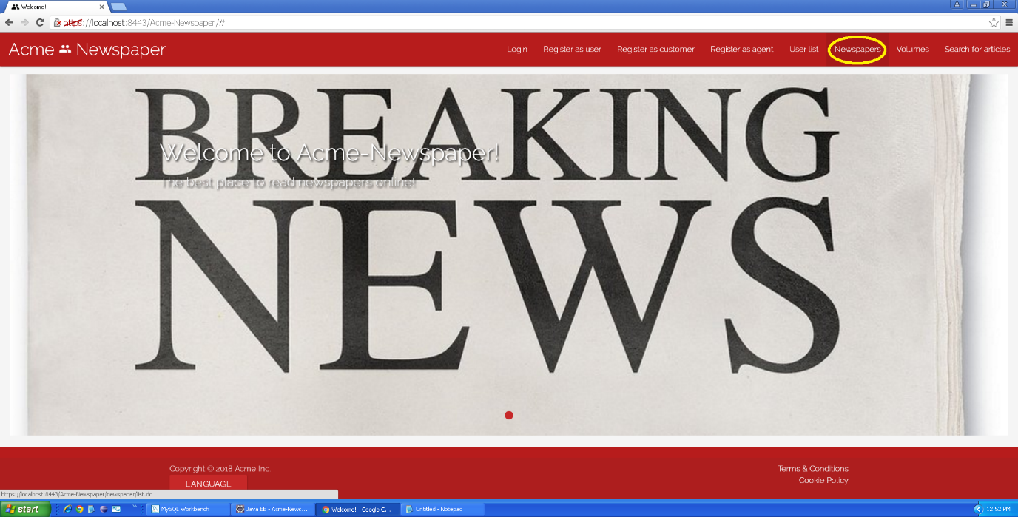

Tests

|  |  |
| --- | --- |
| **Test <#001>** | |
| **Description** | Once “Newspapers” button is pressed, you get into the newspaper list view. |
| **Expected** | You must see 2 pages and 5 newspapers. |
| **Outcome** |  |
| **Notes** |  |

|  |  |
| --- | --- |
| **Test <#002>** | |
| **Description** | Once “Newspapers” button is pressed, you get into the newspaper list view and press the button to the second page. |
| **Expected** | You must see the second page, that only has a newspaper. |
| **Outcome** |  |
| **Notes** |  |

|  |  |
| --- | --- |
| **Test <#003>** | |
| **Description** | Once “Newspapers” button is pressed, you get into the newspaper list view and press the button to sort any of its attributes. |
| **Expected** | You must see newspapers sorted by the clicked attribute. |
| **Outcome** |  |
| **Notes** |  |

|  |  |
| --- | --- |
| **Test <#004>** | |
| **Description** | Once “Newspapers” button is pressed, you get into the newspaper list view and press the button “Details” in the newspaper “El Informatico”. |
| **Expected** | You must be redirected to a view where the details of the newspaper can be seen. |
| **Outcome** |  |
| **Notes** |  |

|  |  |
| --- | --- |
| **Test <#005>** | |
| **Description** | Once “Newspapers” button is pressed, you get into the newspaper list view and you search “informatico”. |
| **Expected** | You must see a list with the newspaper that contains “informatico”. |
| **Outcome** |  |
| **Notes** |  |

|  |  |
| --- | --- |
| **Test <#006>** | |
| **Description** | Before accessing newspapers, you must select Spanish language, then, once “Periódicos” button is pressed, you get into the newspaper list view. |
| **Expected** | You must see 2 pages and 5 newspapers. |
| **Outcome** |  |
| **Notes** |  |

|  |  |
| --- | --- |
| **Test <#007>** | |
| **Description** | Before accessing newspapers, you must select Spanish language, then, once “Periódicos” button is pressed, you get into the newspaper list view and press the button to the second page. |
| **Expected** | You must see the second page, that only has a newspaper. |
| **Outcome** |  |
| **Notes** |  |

|  |  |
| --- | --- |
| **Test <#008>** | |
| **Description** | Before accessing newspapers, you must select Spanish language, then, once “Periódicos” button is pressed, you get into the newspaper list view and press the button to sort any of its attributes. |
| **Expected** | You must see newspapers sorted by the clicked attribute. |
| **Outcome** |  |
| **Notes** |  |

|  |  |
| --- | --- |
| **Test <#009>** | |
| **Description** | Before accessing newspapers, you must select Spanish language, then, once “Periódicos” button is pressed, you get into the newspaper list view and press the button “Details” in the newspaper “El Informatico”. |
| **Expected** | You must be redirected to a view where the details of the newspaper can be seen. |
| **Outcome** |  |
| **Notes** |  |

|  |  |
| --- | --- |
| **Test <#010>** | |
| **Description** | Before accessing newspapers, you must select Spanish language, then, once “Periódicos” button is pressed, you get into the newspaper list view and you search “informatico”. |
| **Expected** | You must see a list with the newspaper that contains “informatico”. |
| **Outcome** |  |
| **Notes** |  |

# Use case 003 – Search for articles

Description

An unauthenticated user goes to the article browser of the system.

Access

Main menu > Search for articles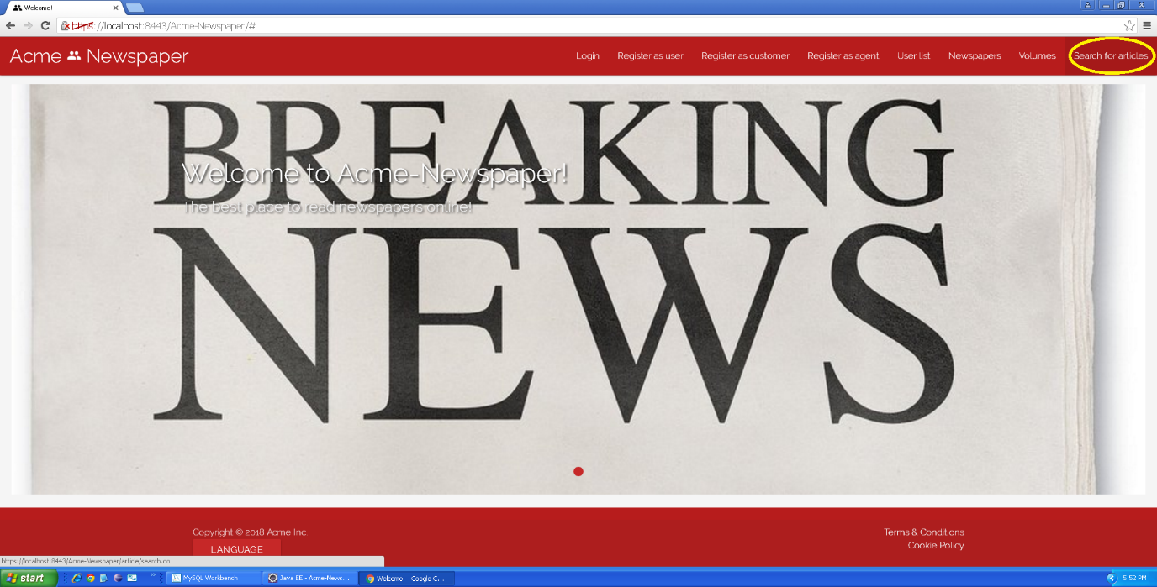

Tests

|  |  |
| --- | --- |
| **Test <#001>** | |
| **Description** | Once “Search for articles” button is pressed, you get into the article list and search view. |
| **Expected** | You must see a list of articles of public newspapers. |
| **Outcome** |  |
| **Notes** |  |

|  |  |
| --- | --- |
| **Test <#002>** | |
| **Description** | Once “Search for articles” button is pressed, you get into the article list and search view, and you search “sobrevivir” |
| **Expected** | You must see a list with the article that contains “sobrevivir” |
| **Outcome** |  |
| **Notes** |  |

|  |  |
| --- | --- |
| **Test <#003>** | |
| **Description** | Once “Search for articles” button is pressed, you get into the article list and search view and press the button to the second page. |
| **Expected** | You must see the second page of published articles. |
| **Outcome** |  |
| **Notes** |  |

|  |  |
| --- | --- |
| **Test <#004>** | |
| **Description** | Once “Search for articles” button is pressed, you get into the article list and search view and press the button to sort any of its attributes. |
| **Expected** | You must see articles sorted by the clicked attribute. |
| **Outcome** |  |
| **Notes** |  |

|  |  |
| --- | --- |
| **Test <#005>** | |
| **Description** | Once “Search for articles” button is pressed, you get into the article list and search view and press the “Display” button of any article. |
| **Expected** | You must be redirected to the detailed view of that article. |
| **Outcome** |  |
| **Notes** |  |

|  |  |
| --- | --- |
| **Test <#006>** | |
| **Description** | Before accessing article list, you must select Spanish language, once “Búsqueda de artículos” button is pressed, you get into the article list and search view. |
| **Expected** | You must see a list of articles of public newspapers. |
| **Outcome** |  |
| **Notes** |  |

|  |  |
| --- | --- |
| **Test <#007>** | |
| **Description** | Before accessing article list, you must select Spanish language, once “Búsqueda de artículos” button is pressed, you get into the article list and search view, and you search “sobrevivir” |
| **Expected** | You must see a list with the article that contains “sobrevivir” |
| **Outcome** |  |
| **Notes** |  |

|  |  |
| --- | --- |
| **Test <#008>** | |
| **Description** | Before accessing article list, you must select Spanish language, once “Búsqueda de artículos” button is pressed, you get into the article list and search view and press the button to the second page. |
| **Expected** | You must see the second page of published articles. |
| **Outcome** |  |
| **Notes** |  |

|  |  |
| --- | --- |
| **Test <#009>** | |
| **Description** | Before accessing article list, you must select Spanish language, once “Búsqueda de artículos” button is pressed, you get into the article list and search view and press the button to sort any of its attributes. |
| **Expected** | You must see articles sorted by the clicked attribute. |
| **Outcome** |  |
| **Notes** |  |

|  |  |
| --- | --- |
| **Test <#010>** | |
| **Description** | Before accessing article list, you must select Spanish language, once “Búsqueda de artículos” button is pressed, you get into the article list and search view and press the “Mostrar” button of any article. |
| **Expected** | You must be redirected to the detailed view of that article. |
| **Outcome** |  |
| **Notes** |  |

# Use case 004 – List and display user

Description

An unauthenticated user goes to the list of users of the system.

Access

Main menu > User list

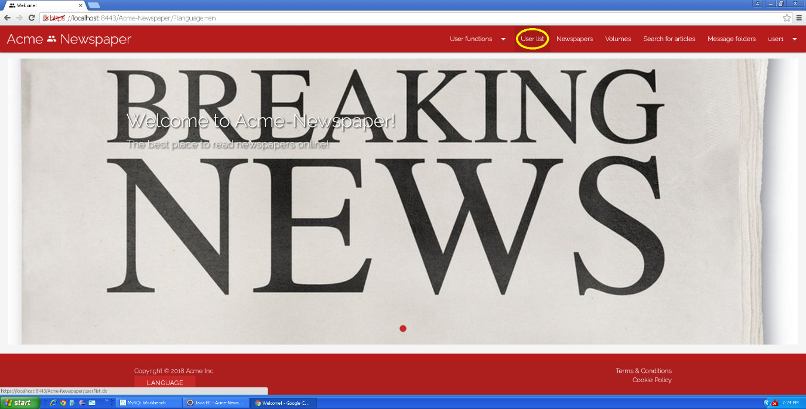

Tests

|  |  |
| --- | --- |
| **Test <#001>** | |
| **Description** | Once “User list” button is pressed, you get into the user list view. |
| **Expected** | You must see 2 pages and 5 users. |
| **Outcome** |  |
| **Notes** |  |

|  |  |
| --- | --- |
| **Test <#002>** | |
| **Description** | Once “User list” button is pressed, you get into the user list view and press the button to the second page. |
| **Expected** | You must see the second page, that has 2 users. |
| **Outcome** |  |
| **Notes** |  |

|  |  |
| --- | --- |
| **Test <#003>** | |
| **Description** | Once “User list” button is pressed, you get into the user list view and press the button to sort any of its attributes. |
| **Expected** | You must see users sorted by the clicked attribute. |
| **Outcome** |  |
| **Notes** |  |

|  |  |
| --- | --- |
| **Test <#004>** | |
| **Description** | Once “User list” button is pressed, you get into the user list view and press the button “Display” in the user “User 1”. |
| **Expected** | You must be redirected to a view where the details of the user can be seen. |
| **Outcome** |  |
| **Notes** |  |

|  |  |
| --- | --- |
| **Test <#005>** | |
| **Description** | Before accessing users, you must select Spanish language, then, once “Usuarios” button is pressed, you get into the user list view. |
| **Expected** | You must see 2 pages and 5 users. |
| **Outcome** |  |
| **Notes** |  |

|  |  |
| --- | --- |
| **Test <#006>** | |
| **Description** | Before accessing users, you must select Spanish language, then, once “Usuarios” button is pressed, you get into the user list view and press the button to the second page. |
| **Expected** | You must see the second page, that has 2 users. |
| **Outcome** |  |
| **Notes** |  |

|  |  |
| --- | --- |
| **Test <#007>** | |
| **Description** | Before accessing users, you must select Spanish language, then, once “Usuarios” button is pressed, you get into the user list view and press the button to sort any of its attributes. |
| **Expected** | You must see users sorted by the clicked attribute. |
| **Outcome** |  |
| **Notes** |  |

|  |  |
| --- | --- |
| **Test <#008>** | |
| **Description** | Before accessing users, you must select Spanish language, then, once “Usuarios” button is pressed, you get into the user list view and press the button “Mostrar” in the user “User 1”. |
| **Expected** | You must be redirected to a view where the details of the user can be seen. |
| **Outcome** |  |
| **Notes** |  |

# Use case 005 – Create a newspaper as a user

Description

An unauthenticated user logs in the system as user, he or she goes to his or her not published newspapers, once there goes to the view to create a newspaper and fills the form.

Access

Login > **Username:** user1; **Password:** user1 > User functions dropdown > My newspapers not published/My newspapers published > Create button.

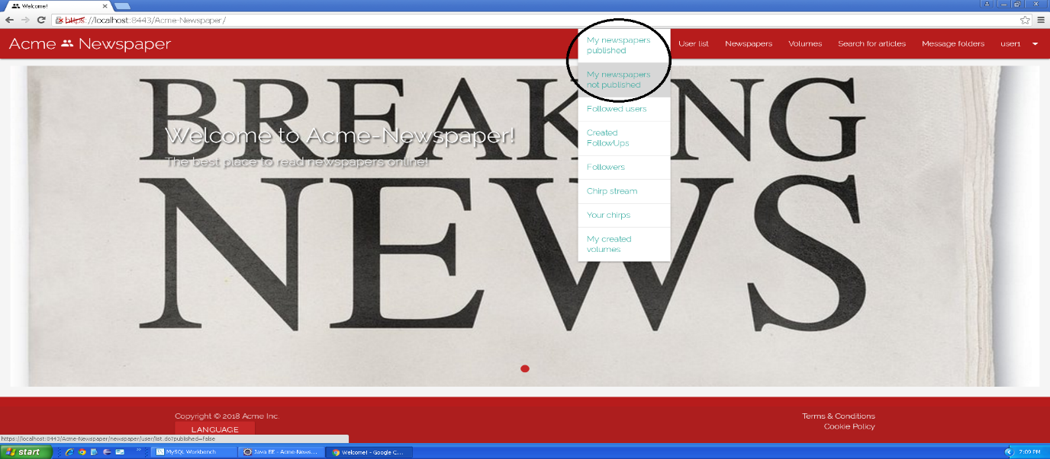

Tests

|  |  |
| --- | --- |
| **Test <#001>** | |
| **Description** | Once you are in the create newspaper view, you press the cancel button. |
| **Expected** | The system must redirect you to the published newspaper list. |
| **Outcome** |  |
| **Notes** | Note that “Cancel” button always redirects to the published newspapers list, even if you pressed the “Create” button in your non-published newspapers. |

|  |  |
| --- | --- |
| **Test <#002>** | |
| **Description** | Once you are in the create newspaper view, you press the save button without data in any field. |
| **Expected** | The system must redirect you to the same view (create newspaper) but showing validation messages in fields |
| **Outcome** |  |
| **Notes** |  |

|  |  |
| --- | --- |
| **Test <#003>** | |
| **Description** | Once you are in the create newspaper view, you press the save button inserting the following data: **Title: “**<script>alarm('Hacked!'); </script>”, **Description:** “Acceptance testing is amazing” and a blank **Image url** |
| **Expected** | The system must redirect you to the same view (create newspaper) but showing “Insecure HTML” validation error |
| **Outcome** |  |
| **Notes** |  |

|  |  |
| --- | --- |
| **Test <#004>** | |
| **Description** | Once you are in the create newspaper view, you press the save button inserting the following data: **Title:** “The tester journal”, **Description:** “Acceptance testing is amazing”, **Image url:** <http://3.bp.blogspot.com/-uDmln3KYjgM/Vetm-e9efVI/AAAAAAAAFvE/PRIkPu8F95M/s1600/irony-alert-ironic.jpg>, and the **Public** checkbox unchecked. |
| **Expected** | The system must redirect you to the non-published newspaper list, where must appear your new newspaper. |
| **Outcome** |  |
| **Notes** |  |

|  |  |
| --- | --- |
| **Test <#005>** | |
| **Description** | You must be in the non-published newspaper list for this test, and once you created the newspaper of the test before, you press the “Edit” button of the new newspaper.  Once editing the newspaper, change the name to “Bad newspaper” and press “Save” button. |
| **Expected** | The system must redirect you to the non-published newspaper list, where must appear your modified newspaper. |
| **Outcome** |  |
| **Notes** |  |

|  |  |
| --- | --- |
| **Test <#006>** | |
| **Description** | You must be in the non-published newspaper list for this test, and once you created the newspaper of the test before, you press the “Edit” button of the new newspaper.  Once editing the newspaper, press the “Delete” button, and click “OK” in the alert that is shown. |
| **Expected** | The system must redirect you to your non-published newspaper list, and your newspaper must not appear. |
| **Outcome** |  |
| **Notes** |  |

|  |  |
| --- | --- |
| **Test <#007>** | |
| **Description** | Before accessing the create newspaper view, you must set the webpage language to “Spanish”, then, once you are in the create newspaper view, you press the “Cancelar” button. |
| **Expected** | The system must redirect you to the published newspaper list. |
| **Outcome** |  |
| **Notes** | Note that “Cancelar” button always redirects to the published newspapers list, even if you pressed the “Crear” button in your non-published newspapers. |

|  |  |
| --- | --- |
| **Test <#008>** | |
| **Description** | Before accessing the create newspaper view, you must set the webpage language to “Spanish”, then, once you are in the create newspaper view, you press the “Guardar” button without data in any field. |
| **Expected** | The system must redirect you to the same view (create newspaper) but showing validation messages in fields |
| **Outcome** |  |
| **Notes** |  |

|  |  |
| --- | --- |
| **Test <#009>** | |
| **Description** | Before accessing the create newspaper view, you must set the webpage language to “Spanish”, then, once you are in the create newspaper view, you press the “Guardar” button inserting the following data: **Título: “**<script>alarm('Hacked!'); </script>”, **Descripción:** “Acceptance testing is amazing” and a blank **Url de la imagen**. |
| **Expected** | The system must redirect you to the same view (create newspaper) but showing “HTML inseguro” validation error |
| **Outcome** |  |
| **Notes** |  |

|  |  |
| --- | --- |
| **Test <#010>** | |
| **Description** | Before accessing the create newspaper view, you must set the webpage language to “Spanish”, then, once you are in the create newspaper view, you press the “Guardar” button inserting the following data: **Título:** “The tester journal”, **Descripción:** “Acceptance testing is amazing”, **Url de la imagen:** <http://3.bp.blogspot.com/-uDmln3KYjgM/Vetm-e9efVI/AAAAAAAAFvE/PRIkPu8F95M/s1600/irony-alert-ironic.jpg>, and the “**Público”** checkbox unchecked. |
| **Expected** | The system must redirect you to the non-published newspaper list, where must appear your new newspaper. |
| **Outcome** |  |
| **Notes** |  |

|  |  |
| --- | --- |
| **Test <#011>** | |
| **Description** | The first thing you must do for this test is setting the language to Spanish, once this has been done, you must be in the non-published newspaper list, and once you created the newspaper of the test before, you press the “Editar” button of the new newspaper.  Once editing the newspaper, change the name to “Bad newspaper” and press “Guardar” button. |
| **Expected** | The system must redirect you to the non-published newspaper list, where must appear your modified newspaper. |
| **Outcome** |  |
| **Notes** |  |

|  |  |
| --- | --- |
| **Test <#012>** | |
| **Description** | The first thing you must do for this test is setting the language to Spanish, once this has been done, you must be in the non-published newspaper list, and once you created the newspaper of the test before, you press the “Editar” button of the new newspaper.  Once editing the newspaper, press the “Borrar” button, and click “OK” in the alert that is shown. |
| **Expected** | The system must redirect you to your non-published newspaper list, and your newspaper must not appear. |
| **Outcome** |  |
| **Notes** |  |

# Use case 006 – Publish a newspaper

Description

An unauthenticated user logs in the system as user, he or she goes to his or her not published newspapers, once there he or she publishes a newspaper.

Access

Login > **Username:** user1; **Password:** user1 > User functions dropdown > My newspapers not published.

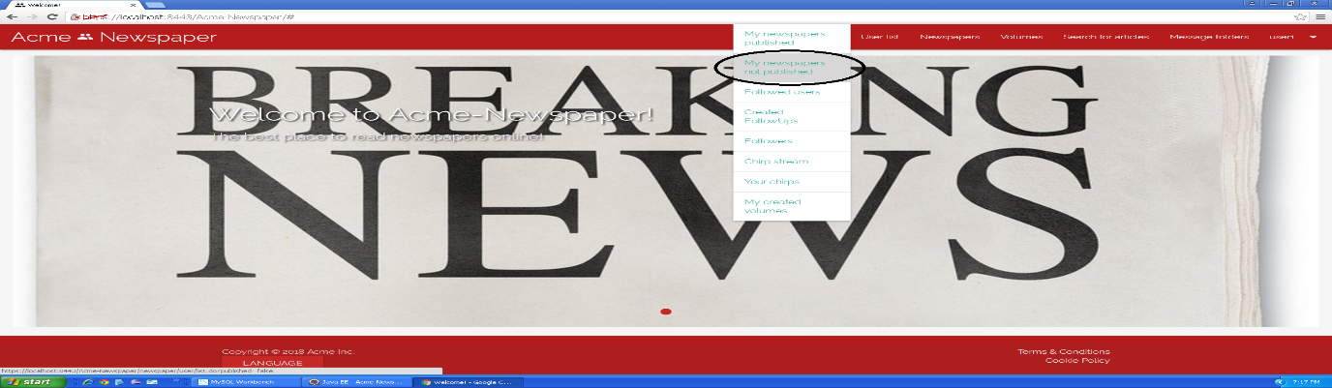

Tests

|  |  |
| --- | --- |
| **Test <#001>** | |
| **Description** | Once you are in the non-published newspapers list view, you must press “Publish” button in the newspaper with title “Performance testing is better than acceptance testing!”. |
| **Expected** | The system must redirect you to your published newspaper list, where must appear the new newspaper in any of the pages. |
| **Outcome** |  |
| **Notes** | Note that you have a newspaper ready to be published, that is, with its articles saved in final mode. |

|  |  |
| --- | --- |
| **Test <#002>** | |
| **Description** | The first thing you must do for this test is setting the language to Spanish, once you are in the non-published newspapers list view, you must press “Publicar” button in the newspaper with title “Performance testing is better than acceptance testing!”. |
| **Expected** | The system must redirect you to your published newspaper list, where must appear the new newspaper in any of the pages. |
| **Outcome** |  |
| **Notes** | Note that you have a newspaper ready to be published, that is, with its articles saved in final mode. |

# Use case 007 – Write an article

Description

An unauthenticated user logs in the system as user, he or she goes to his or her not published newspapers, once there he or she goes to the detailed view of a newspaper and creates an article.

Access

Login > **Username:** user1; **Password:** user1 > User functions dropdown > My newspapers not published > “This is a newspaper for Acceptance Testing” Details button > “Create” button under “List of articles”.

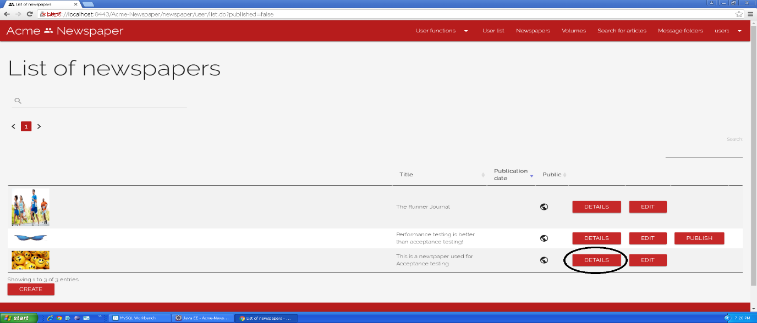

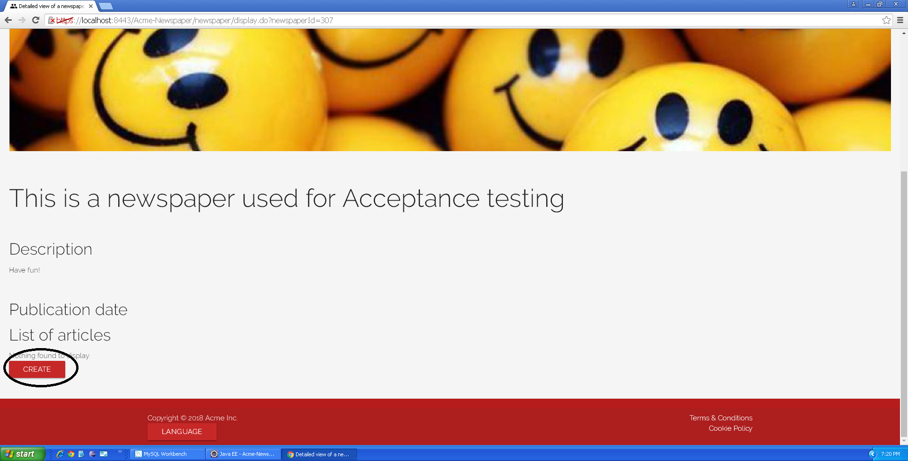

Tests

|  |  |
| --- | --- |
| **Test <#001>** | |
| **Description** | Once you are in the create article view, you press the cancel button. |
| **Expected** | The system must redirect you to the detailed view of the newspaper. |
| **Outcome** |  |
| **Notes** |  |

|  |  |
| --- | --- |
| **Test <#002>** | |
| **Description** | Once you are in the create article view, you press the save button without data in any field. |
| **Expected** | The system must redirect you to the same view (create article) but showing validation messages in fields. |
| **Outcome** |  |
| **Notes** |  |

|  |  |
| --- | --- |
| **Test <#003>** | |
| **Description** | Once you are in the create article view, you press the save button inserting the following data: **Title: “**<script>alarm('Hacked!'); </script>”, **Summary:** “This is a test” and “Hello world!” in the **textarea.** |
| **Expected** | The system must redirect you to the same view (create article) but showing “Insecure HTML” validation error. |
| **Outcome** |  |
| **Notes** |  |

|  |  |
| --- | --- |
| **Test <#004>** | |
| **Description** | Once you are in the create article view, you press the save button inserting the following data: **Title:** “I’m falling asleep”, **Summary:** “I want to drink some EXTRA SALTY water”, **Textarea:** “Salty water makes me be awake”, and the **Final mode** checkbox unchecked. |
| **Expected** | The system must redirect you to the detailed view of the newspaper. |
| **Outcome** |  |
| **Notes** |  |

|  |  |
| --- | --- |
| **Test <#005>** | |
| **Description** | Once you are in the detailed view of the newspaper, you press the edit button of the article created previously, change the title from “I’m falling asleep” to “Long life pizza”, and press the button “Save” with no other changes. |
| **Expected** | The system must redirect you to the detailed view of the newspaper. |
| **Outcome** |  |
| **Notes** |  |

|  |  |
| --- | --- |
| **Test <#006>** | |
| **Description** | Once you are in the detailed view of the newspaper, you press the edit button of the article created previously, once editing the article, press the “Delete” button, and click “OK” in the alert that is shown. |
| **Expected** | The system must redirect you to the detailed view of the newspaper with the article deleted. |
| **Outcome** |  |
| **Notes** |  |

|  |  |
| --- | --- |
| **Test <#007>** | |
| **Description** | Once you are in the create article view, you press the save button inserting the following data: **Title:** “New article 2”, **Summary:** “This is another test”, **Textarea:** “Just filling fields SO FUN”, and the **Final mode** checkbox checked. |
| **Expected** | The system must redirect you to the detailed view of the newspaper with the new article, that cannot be edited. |
| **Outcome** |  |
| **Notes** |  |

|  |  |
| --- | --- |
| **Test <#008>** | |
| **Description** | Before doing any other thing, you must set the webpage language to “Spanish”, then, once you are in the create article view, you press the “Cancelar” button. |
| **Expected** | The system must redirect you to the detailed view of the newspaper. |
| **Outcome** |  |
| **Notes** |  |

|  |  |
| --- | --- |
| **Test <#009>** | |
| **Description** | Before doing any other thing, you must set the webpage language to “Spanish”, then, once you are in the create article view, you press the “Guardar” button without data in any field. |
| **Expected** | The system must redirect you to the same view (create article) but showing validation messages in fields. |
| **Outcome** |  |
| **Notes** |  |

|  |  |
| --- | --- |
| **Test <#010>** | |
| **Description** | Before doing any other thing, you must set the webpage language to “Spanish”, then, once you are in the create article view, you press the “Guardar” button inserting the following data: **Título: “**<script>alarm('Hacked!'); </script>”, **Sumario:** “This is a test” and “Hello world!” in the **textarea.** |
| **Expected** | The system must redirect you to the same view (create article) but showing “HTML inseguro” validation error. |
| **Outcome** |  |
| **Notes** |  |

|  |  |
| --- | --- |
| **Test <#011>** | |
| **Description** | Before doing any other thing, you must set the webpage language to “Spanish”, then, once you are in the create article view, you press the “Guardar” button inserting the following data: **Título:** “I’m falling asleep”, **Sumario:** “I want to drink some EXTRA SALTY water”, **Textarea:** “Salty water makes me be awake”, and the **Modo definitivo** checkbox unchecked. |
| **Expected** | The system must redirect you to the detailed view of the newspaper. |
| **Outcome** |  |
| **Notes** |  |

|  |  |
| --- | --- |
| **Test <#012>** | |
| **Description** | Before doing any other thing, you must set the webpage language to “Spanish”, then, once you are in the detailed view of the newspaper, you press the “Editar” button of the article created previously, change the title from “I’m falling asleep” to “Long life pizza”, and press the button “Guardar” with no other changes. |
| **Expected** | The system must redirect you to the detailed view of the newspaper. |
| **Outcome** |  |
| **Notes** |  |

|  |  |
| --- | --- |
| **Test <#013>** | |
| **Description** | Before doing any other thing, you must set the webpage language to “Spanish”, then, once you are in the detailed view of the newspaper, you press the “Editar” button of the article created previously, once editing the article, press the “Borrar” button, and click “OK” in the alert that is shown. |
| **Expected** | The system must redirect you to the detailed view of the newspaper with the article deleted. |
| **Outcome** |  |
| **Notes** |  |

|  |  |
| --- | --- |
| **Test <#014>** | |
| **Description** | Once you are in the create article view, you press the save button inserting the following data: **Título:** “New article 2”, **Sumario:** “This is another test”, **Textarea:** “Just filling fields SO FUN”, and the **Modo definitivo** checkbox checked. |
| **Expected** | The system must redirect you to the detailed view of the newspaper with the new article, that cannot be edited. |
| **Outcome** |  |
| **Notes** |  |

# Use case 008 – Post a chirp as user

Description

An unauthenticated user logs in the system as user, he or she goes to his or her chirps, once there he or she publishes a chirp.

Access

Login > **Username:** user1; **Password:** user1 > User functions dropdown > Your chirps > “Create new chirp” button.

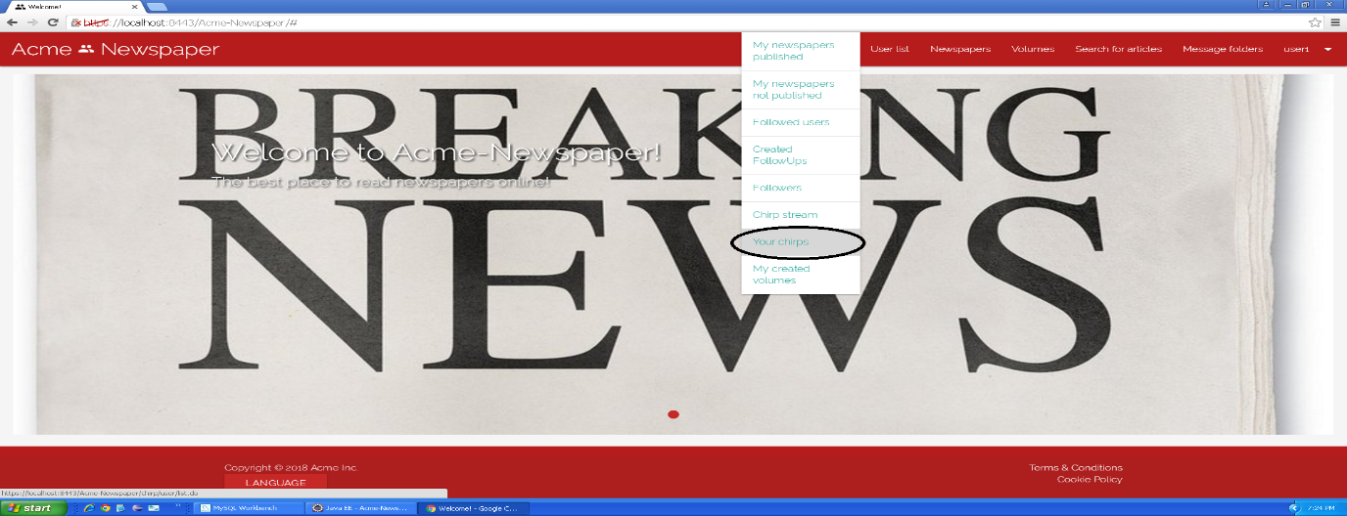

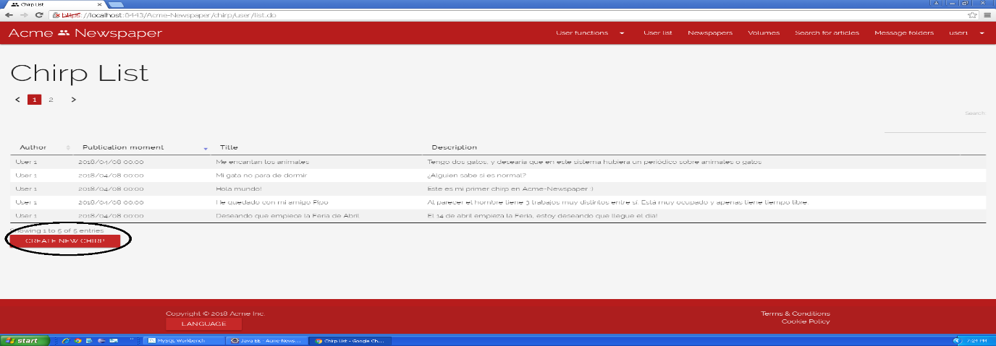

Tests

|  |  |
| --- | --- |
| **Test <#001>** | |
| **Description** | Once you are in the create chirp view, you press the cancel button. |
| **Expected** | The system must redirect you to your chirp list view. |
| **Outcome** |  |
| **Notes** |  |

|  |  |
| --- | --- |
| **Test <#002>** | |
| **Description** | Once you are in the create chirp view, you press the save button without data in any field. |
| **Expected** | The system must redirect you to the same view (create chirp) but showing validation messages in fields. |
| **Outcome** |  |
| **Notes** |  |

|  |  |
| --- | --- |
| **Test <#003>** | |
| **Description** | Once you are in the create newspaper view, you press the save button inserting the following data: **Title: “**<script>alarm('Hacked!'); </script>”, **Description:** “This is a test”. |
| **Expected** | The system must redirect you to the same view (create chirp) but showing “Insecure HTML” validation error. |
| **Outcome** |  |
| **Notes** |  |

|  |  |
| --- | --- |
| **Test <#004>** | |
| **Description** | Once you are in the create chirp view, you press the save button inserting the following data: **Title:** “Chirp test”, **Description:** “This is just a test, don’t worry”. |
| **Expected** | The system must redirect you to your chirp list view which will show the new chirp. |
| **Outcome** |  |
| **Notes** |  |

|  |  |
| --- | --- |
| **Test <#005>** | |
| **Description** | Before doing any other thing, you must set the webpage language to “Spanish”, then, once you are in the create chirp view, you press the “Cancelar” button. |
| **Expected** | The system must redirect you to your chirp list view. |
| **Outcome** |  |
| **Notes** |  |

|  |  |
| --- | --- |
| **Test <#006>** | |
| **Description** | Before doing any other thing, you must set the webpage language to “Spanish”, then, once you are in the create chirp view, you press the “Guardar” button without data in any field. |
| **Expected** | The system must redirect you to the same view (create chirp) but showing validation messages in fields. |
| **Outcome** |  |
| **Notes** |  |

|  |  |
| --- | --- |
| **Test <#007>** | |
| **Description** | Before doing any other thing, you must set the webpage language to “Spanish”, then, once you are in the create newspaper view, you press the “Guardar” button inserting the following data: **Título: “**<script>alarm('Hacked!'); </script>”, **Descripción:** “This is a test”. |
| **Expected** | The system must redirect you to the same view (create chirp) but showing “HTML inseguro” validation error. |
| **Outcome** |  |
| **Notes** |  |

|  |  |
| --- | --- |
| **Test <#008>** | |
| **Description** | Before doing any other thing, you must set the webpage language to “Spanish”, then, once you are in the create chirp view, you press the “Guardar” button inserting the following data: **Título:** “Chirp test”, **Descripción:** “This is just a test, don’t worry”. |
| **Expected** | The system must redirect you to your chirp list view which will show the new chirp. |
| **Outcome** |  |
| **Notes** |  |

# Use case 009 – Follow or unfollow a user

Description

An unauthenticated user logs in the system as user, he or she goes to the user list of the system and he or she follows or unfollows another user.

Access

Login > **Username:** user2; **Password:** user2 > User list.

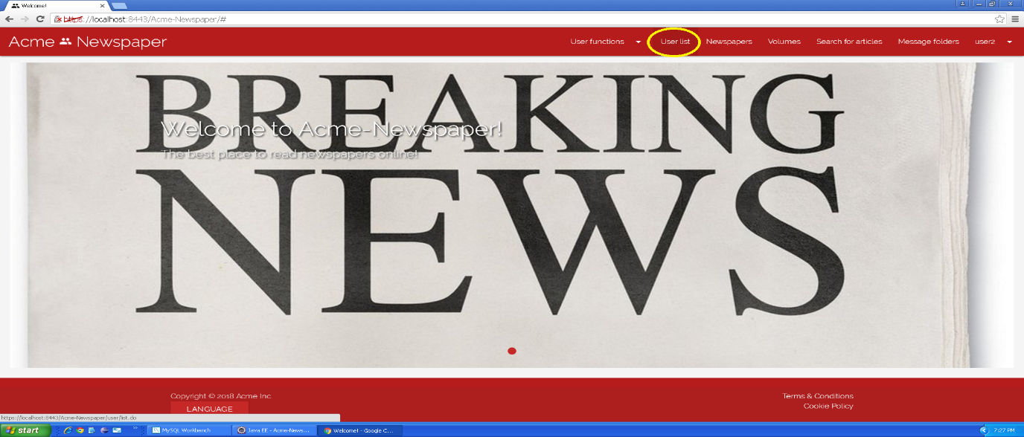

Tests

|  |  |
| --- | --- |
| **Test <#001>** | |
| **Description** | Once you are in the user list, you must press “Follow” button to follow “User 3”. |
| **Expected** | The system must redirect you to the same view, and now you must have a button that says “Unfollow” on “User 3”, which means that now you follow User 3. |
| **Outcome** |  |
| **Notes** |  |

|  |  |
| --- | --- |
| **Test <#002>** | |
| **Description** | Once you are in the user list, you must press “Unfollow” button to unfollow “User 3”. |
| **Expected** | The system must redirect you to the same view, and now you must have a button that says “Follow” on “User 3”, which means that now you do not follow User 3. |
| **Outcome** |  |
| **Notes** |  |

|  |  |
| --- | --- |
| **Test <#003>** | |
| **Description** | Before doing any other thing, you must set the webpage language to “Spanish”, then, once you are in the user list, you must press “Seguir” button to follow “User 3”. |
| **Expected** | The system must redirect you to the same view, and now you must have a button that says “Dejar de seguir” on “User 3”, which means that now you follow User 3. |
| **Outcome** |  |
| **Notes** |  |

|  |  |
| --- | --- |
| **Test <#004>** | |
| **Description** | Before doing any other thing, you must set the webpage language to “Spanish”, then, once you are in the user list, you must press “Dejar de seguir” button to unfollow “User 3”. |
| **Expected** | The system must redirect you to the same view, and now you must have a button that says “Seguir” on “User 3”, which means that now you do not follow User 3. |
| **Outcome** |  |
| **Notes** |  |

# Use case 010 – List users that a user follows

Description

An authenticated user goes to the list of users that he or she follows.

Access

Login > **Username:** user1; **Password:** user1 > User functions dropdown > Followed users.

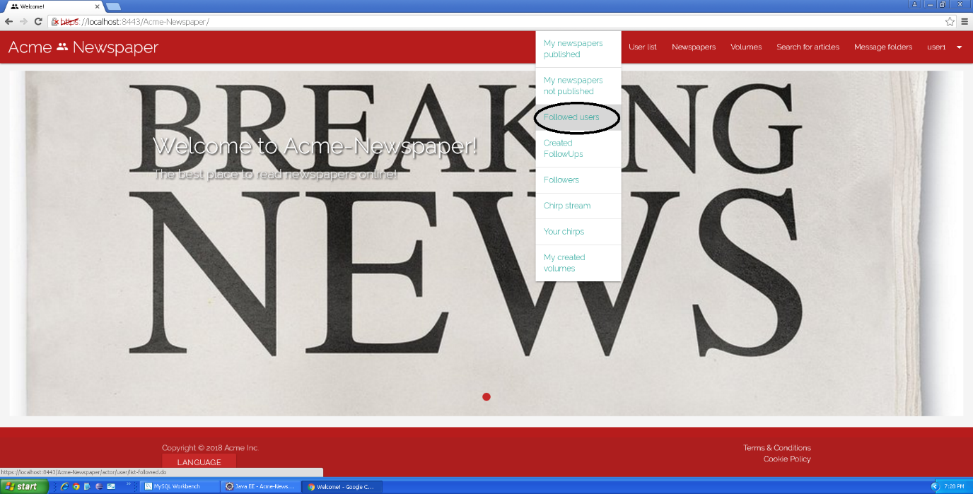

Tests

|  |  |
| --- | --- |
| **Test <#001>** | |
| **Description** | Once “Followed users” button is pressed, you get into the followed user list view. |
| **Expected** | You must be redirected to the list of followed users, where you can see 2 pages and 5 users. |
| **Outcome** |  |
| **Notes** |  |

|  |  |
| --- | --- |
| **Test <#002>** | |
| **Description** | Once “Followed users” button is pressed, you get into the followed user list view and press the button to the second page. |
| **Expected** | You must be redirected to the second page of the list, which only has a user. |
| **Outcome** |  |
| **Notes** |  |

|  |  |
| --- | --- |
| **Test <#003>** | |
| **Description** | Once “Followed users” button is pressed, you get into the followed user list view and press the button to sort any of its attributes. |
| **Expected** | You must see users sorted by the clicked attribute. |
| **Outcome** |  |
| **Notes** |  |

|  |  |
| --- | --- |
| **Test <#004>** | |
| **Description** | Before doing any other thing, you must set the webpage language to “Spanish”, then, once “Usuarios seguidos” button is pressed, you get into the followed user list view. |
| **Expected** | You must be redirected to the list of followed users, where you can see 2 pages and 5 users. |
| **Outcome** |  |
| **Notes** |  |

|  |  |
| --- | --- |
| **Test <#005>** | |
| **Description** | Before doing any other thing, you must set the webpage language to “Spanish”, then, once “Usuarios seguidos” button is pressed, you get into the followed user list view and press the button to the second page. |
| **Expected** | You must be redirected to the second page of the list, which only has a user. |
| **Outcome** |  |
| **Notes** |  |

|  |  |
| --- | --- |
| **Test <#006>** | |
| **Description** | Before doing any other thing, you must set the webpage language to “Spanish”, then, once “Usuarios seguidos” button is pressed, you get into the followed user list view and press the button to sort any of its attributes. |
| **Expected** | You must see users sorted by the clicked attribute. |
| **Outcome** |  |
| **Notes** |  |

# Use case 011 – List users who follow the logged user

Description

An authenticated user goes to the list of users that follow him or her.

Access

Login > **Username:** user1; **Password:** user1 > User functions dropdown > Followers.

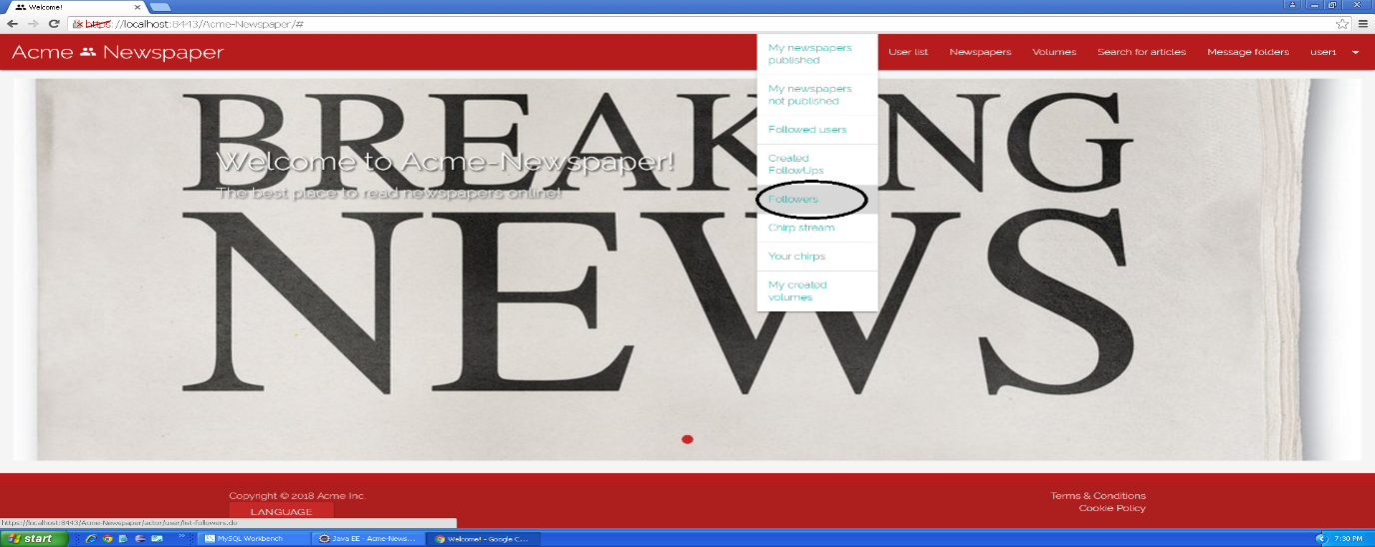

Tests

|  |  |
| --- | --- |
| **Test <#001>** | |
| **Description** | Once “Followers” button is pressed, you get into the followers list view. |
| **Expected** | You must be redirected to the list of followers, where you can see 2 pages and 5 users. |
| **Outcome** |  |
| **Notes** |  |

|  |  |
| --- | --- |
| **Test <#002>** | |
| **Description** | Once “Followers” button is pressed, you get into the followers list view and press the button to the second page. |
| **Expected** | You must be redirected to the second page of the list, which only has a user. |
| **Outcome** |  |
| **Notes** |  |

|  |  |
| --- | --- |
| **Test <#003>** | |
| **Description** | Once “Followers” button is pressed, you get into the followers list view and press the button to sort any of its attributes. |
| **Expected** | You must see users sorted by the clicked attribute. |
| **Outcome** |  |
| **Notes** |  |

|  |  |
| --- | --- |
| **Test <#004>** | |
| **Description** | Before doing any other thing, you must set the webpage language to “Spanish”, then, once “Seguidores” button is pressed, you get into the followers list view. |
| **Expected** | You must be redirected to the list of followers, where you can see 2 pages and 5 users. |
| **Outcome** |  |
| **Notes** |  |

|  |  |
| --- | --- |
| **Test <#005>** | |
| **Description** | Before doing any other thing, you must set the webpage language to “Spanish”, then, once “Seguidores” button is pressed, you get into the followers list view and press the button to the second page. |
| **Expected** | You must be redirected to the second page of the list, which only has a user. |
| **Outcome** |  |
| **Notes** |  |

|  |  |
| --- | --- |
| **Test <#006>** | |
| **Description** | Before doing any other thing, you must set the webpage language to “Spanish”, then, once “Seguidores” button is pressed, you get into the followers list view and press the button to sort any of its attributes. |
| **Expected** | You must see users sorted by the clicked attribute. |
| **Outcome** |  |
| **Notes** |  |

# Use case 012 – Display a stream with the chirps of the followed users

Description

An authenticated user goes to the chirp stream to see the chirps posted by the users he or she follows.

Access

Login > **Username:** user1; **Password:** user1 > User functions dropdown > Chirp stream.

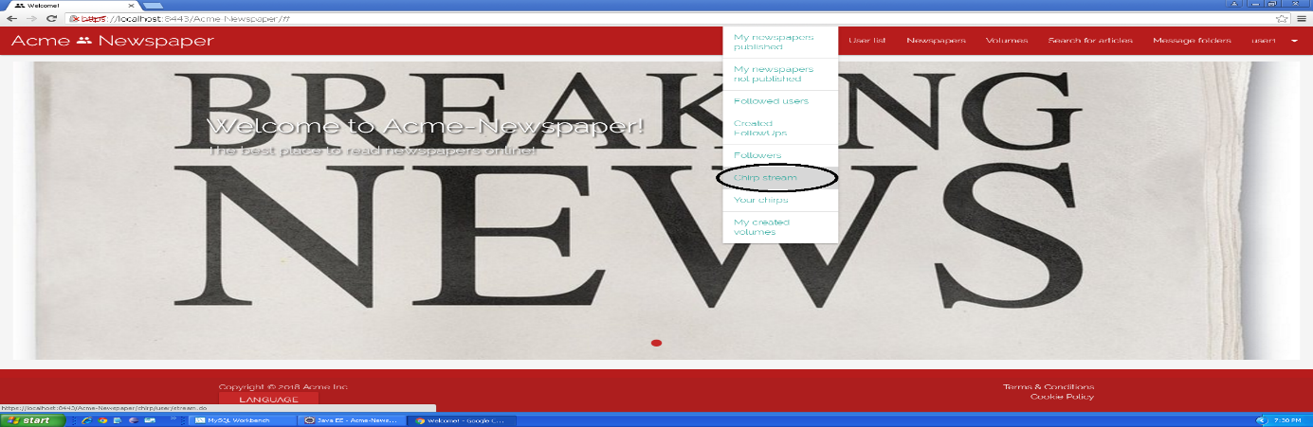

Tests

|  |  |
| --- | --- |
| **Test <#001>** | |
| **Description** | Once “Chirp stream” button is pressed, you get into the chirp list view. |
| **Expected** | You must be redirected to the stream of chirps, where you can see 2 pages and 5 chirps written by “User 2” sorted by publication moment. |
| **Outcome** |  |
| **Notes** |  |

|  |  |
| --- | --- |
| **Test <#002>** | |
| **Description** | Once “Chirp stream” button is pressed, you get into the chirp list view and press the button to the second page. |
| **Expected** | You must be redirected to the second page of the list, which only has a chirp. |
| **Outcome** |  |
| **Notes** |  |

|  |  |
| --- | --- |
| **Test <#003>** | |
| **Description** | Once “Chirp stream” button is pressed, you get into the chirp list view and press the button to sort any of its attributes. |
| **Expected** | You must see chirps sorted by the clicked attribute. |
| **Outcome** |  |
| **Notes** |  |

|  |  |
| --- | --- |
| **Test <#004>** | |
| **Description** | Before doing any other thing, you must set the webpage language to “Spanish”, then, once “Lista de chirps” button is pressed, you get into the chirp list view. |
| **Expected** | You must be redirected to the stream of chirps, where you can see 2 pages and 5 chirps written by “User 2” sorted by publication moment. |
| **Outcome** |  |
| **Notes** |  |

|  |  |
| --- | --- |
| **Test <#005>** | |
| **Description** | Before doing any other thing, you must set the webpage language to “Spanish”, then, once “Lista de chirps” button is pressed, you get into the chirp list view and press the button to the second page. |
| **Expected** | You must be redirected to the second page of the list, which only has a chirp. |
| **Outcome** |  |
| **Notes** |  |

|  |  |
| --- | --- |
| **Test <#006>** | |
| **Description** | Before doing any other thing, you must set the webpage language to “Spanish”, then, once “Lista de chirps” button is pressed, you get into the chirp list view and press the button to sort any of its attributes. |
| **Expected** | You must see chirps sorted by the clicked attribute. |
| **Outcome** |  |
| **Notes** |  |

# Use case 013 – Register as an agent

Description

An unauthenticated user goes to the register as an agent view and fills the form, once the form is filled, he or she presses the register button.

Access

Main Menu > Register in the system > Register as agent.

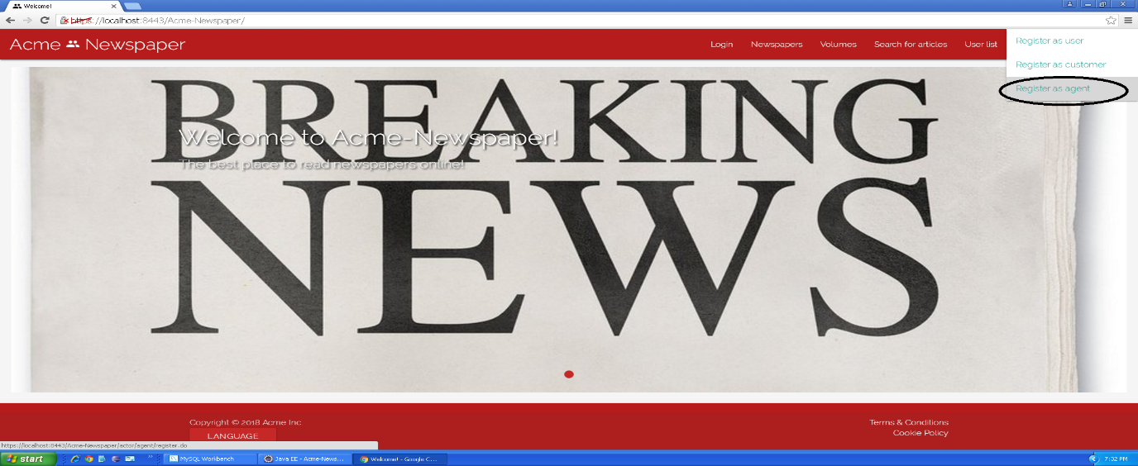

Tests

|  |  |
| --- | --- |
| **Test <#001>** | |
| **Description** | The form must be filled in with the following data: **Name:** ‘Bond’; **Surname:** ’James Bond’; **Phone number:** ‘634634007’; **Postal address:** ‘007 Avocado Street, Iowa’; **Email:** ‘bondja@007.com’; **Birthdate:** ’07/07/1987’ **Username:** ‘bondja’; **Password:** ‘bondja’; **Confirm password:** ‘bondja’. You must also accept **Terms & Conditions**. |
| **Expected** | At the end of the use case, the system must redirect you to the main view. |
| **Outcome** |  |
| **Notes** |  |

|  |  |
| --- | --- |
| **Test <#002>** | |
| **Description** | The form must be blank, only the “I accept Terms & Conditions” box must be checked, otherwise the “Register” button will be inaccessible. |
| **Expected** | At the end of the use case, the system must redirect you to the same form, but each field must have its validation error. |
| **Outcome** |  |
| **Notes** |  |

|  |  |
| --- | --- |
| **Test <#003>** | |
| **Description** | Once you access the form, you must press the “Cancel” button. |
| **Expected** | You must be redirected to main view. |
| **Outcome** |  |
| **Notes** | In this test field content can be both filled or blank. |

|  |  |
| --- | --- |
| **Test <#004>** | |
| **Description** | The form must be filled in with the following data: **Name:** ‘<script>alarm('Hacked!'); </script>’; **Surname:** ’James Bond’; **Phone number:** ‘634634007’; **Postal address:** ‘007 Avocado Street, Iowa’; **Email:** ‘bondja@007.com’; **Birthdate:** ’07/07/1987’ **Username:** ‘bondja’; **Password:** ‘bondja’; **Confirm password:** ‘bondja’. You must also accept **Terms & Conditions**. |
| **Expected** | At the end of the use case, the system must redirect you to the register user form with an error message in “Name” field where you can read “Insecure HTML” |
| **Outcome** |  |
| **Notes** |  |

|  |  |
| --- | --- |
| **Test <#005>** | |
| **Description** | Before accessing the form, language must be set to “Spanish”, after this, the form must be filled in with the following data: **Nombre:** ‘Bond’; **Apellidos:** ’James Bond’; **Número de teléfono:** ‘634634007’; **Dirección:** ‘007 Avocado Street, Iowa’; **Correo electrónico:** ‘bondja@007.com’; **Fecha de nacimiento:** ’07/07/1987’ **Nombre de usuario:** ‘bondja’; **Contraseña:** ‘bondja’; **Confirmar contraseña:** ‘bondja’. You must also accept **Términos y Condiciones**. |
| **Expected** | At the end of the use case, the system must redirect you to the main view. |
| **Outcome** |  |
| **Notes** |  |

|  |  |
| --- | --- |
| **Test <#006>** | |
| **Description** | Before accessing the form, language must be set to “Spanish”, after this, the form must be blank, only the “Acepto los términos y condiciones” box must be checked, otherwise the “Registrarse” button will be inaccessible. |
| **Expected** | At the end of the use case, the system must redirect you to the same form, but each field must have its validation error. |
| **Outcome** |  |
| **Notes** |  |

|  |  |
| --- | --- |
| **Test <#007>** | |
| **Description** | Before accessing the form, language must be set to “Spanish”, after this, once you access the form, you must press the “Cancelar” button. |
| **Expected** | You must be redirected to main view. |
| **Outcome** |  |
| **Notes** | In this test field content can be both filled or blank. |

|  |  |
| --- | --- |
| **Test <#008>** | |
| **Description** | Before accessing the form, language must be set to “Spanish”, after this, the form must be filled in with the following data: **Nombre:** ‘<script>alarm('Hacked!'); </script>’; **Apellidos:** ’James Bond’; **Número de teléfono:** ‘634634007’; **Dirección:** ‘007 Avocado Street, Iowa’; **Correo electrónico:** ‘bondja@007.com’; **Fecha de nacimiento:** ’07/07/1987’ **Nombre de usuario:** ‘bondja’; **Contraseña:** ‘bondja’; **Confirmar contraseña:** ‘bondja’. You must also accept **Términos y Condiciones**. |
| **Expected** | At the end of the use case, the system must redirect you to the register user form with an error message in “Nombre” field where you can read “HTML inseguro” |
| **Outcome** |  |
| **Notes** |  |

# Use case 014 – Create advertisement

Description

An unauthenticated user logs in the system as an agent, he or she goes to his or her advertisements, once there he or she creates an advertisement.

Access

Login > **Username:** agent1; **Password:** agent1 > Agent functions dropdown > My advertisements > “Create” button.

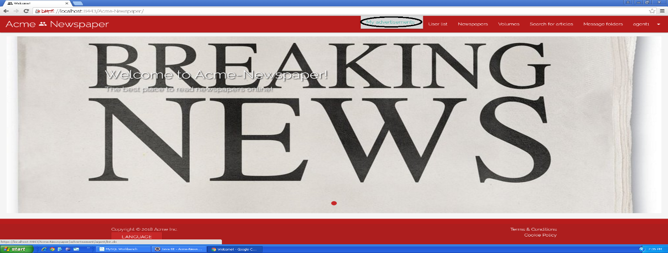

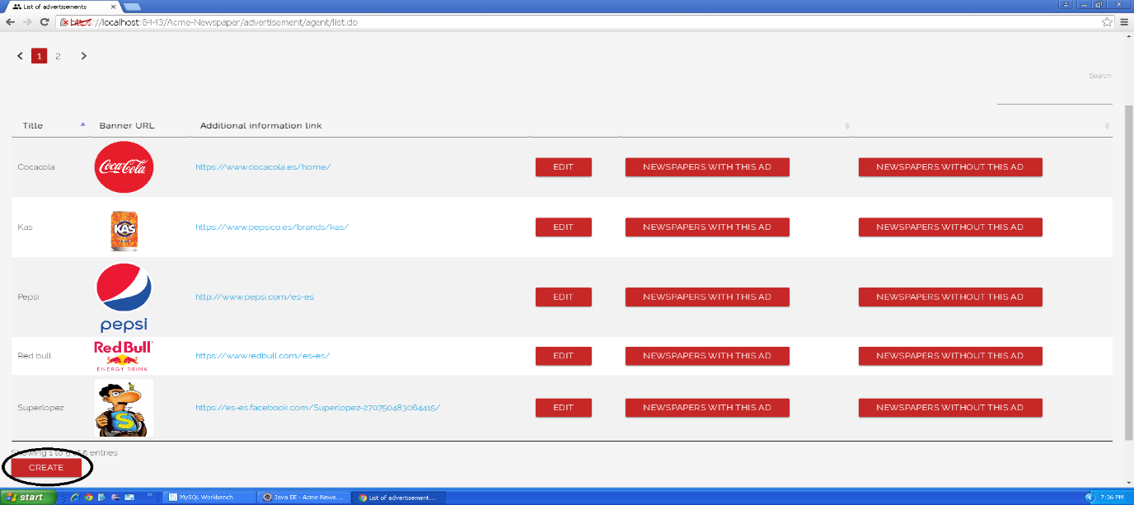

Tests

|  |  |
| --- | --- |
| **Test <#001>** | |
| **Description** | Once you are in the create advertisement view, you press the cancel button. |
| **Expected** | The system must redirect you to your advertisement list view. |
| **Outcome** |  |
| **Notes** |  |

|  |  |
| --- | --- |
| **Test <#002>** | |
| **Description** | Once you are in the create advertisement view, you press the save button without data in any field. |
| **Expected** | The system must redirect you to the same view (create advertisement) but showing validation messages in fields. |
| **Outcome** |  |
| **Notes** |  |

|  |  |
| --- | --- |
| **Test <#003>** | |
| **Description** | Once you are in the create newspaper view, you press the save button inserting the following data: **Title: “**<script>alarm('Hacked!'); </script>”, **Banner url:** “https://test.jpg”, **Additional info link:** “https://test.com”, **Holder name:** “Agent test” **Brand name:** “Test”, **Number:** “1111111111111117”, **Expiration month:** “7”, **Expiration year:** “18”, **CVV:** “123”. |
| **Expected** | The system must redirect you to the same view (create advertisement) but showing “Insecure HTML” validation error. |
| **Outcome** |  |
| **Notes** |  |

|  |  |
| --- | --- |
| **Test <#004>** | |
| **Description** | Once you are in the create newspaper view, you press the save button inserting the following data: **Title: “**Test”, **Banner url:** “https://test.jpg”, **Additional info link:** “https://test.com”, **Holder name:** “Agent test” **Brand name:** “Test”, **Number:** “1111111111111117”, **Expiration month:** “6”, **Expiration year:** “18”, **CVV:** “123”. |
| **Expected** | The system must redirect you to the same view (create advertisement) but showing “The credit card must not be expired” validation error. |
| **Outcome** |  |
| **Notes** |  |

|  |  |
| --- | --- |
| **Test <#005>** | |
| **Description** | Once you are in the create chirp view, you press the save button inserting the following data: **Title: “**Test”, **Banner url:** “https://test.jpg”, **Additional info link:** “https://test.com”, **Holder name:** “Agent test” **Brand name:** “Test”, **Number:** “1111111111111117”, **Expiration month:** “10”, **Expiration year:** “18”, **CVV:** “123”. |
| **Expected** | The system must redirect you to your advertisement list view which will show the new advertisement. |
| **Outcome** |  |
| **Notes** |  |

|  |  |
| --- | --- |
| **Test <#006>** | |
| **Description** | Once you are in the newspaper list view, you press the “details” button in the first newspaper, in the detailed view you press the “add an ad to this newspaper” button, it will redirect you to the advertisements list view, in the first row, you must click on “use” button. |
| **Expected** | The system must redirect you to your advertisement list view but the button “use” now is “don’t use this ad”. |
| **Outcome** |  |
| **Notes** |  |

|  |  |
| --- | --- |
| **Test <#007>** | |
| **Description** | Before doing any other thing, you must set the webpage language to “Spanish”, then, once you are in the create advertisement view, you press the “Cancelar” button. |
| **Expected** | The system must redirect you to your advertisement list view. |
| **Outcome** |  |
| **Notes** |  |

|  |  |
| --- | --- |
| **Test <#008>** | |
| **Description** | Before doing any other thing, you must set the webpage language to “Spanish”, then, once you are in the create advertisement view, you press the “Guardar” button without data in any field. |
| **Expected** | The system must redirect you to the same view (create advertisement) but showing validation messages in fields. |
| **Outcome** |  |
| **Notes** |  |
| **Test <#009>** | |
| **Description** | Before doing any other thing, you must set the webpage language to “Spanish”, then, once you are in the create newspaper view, you press the “Guardar” button inserting the following data: **Título: “T**est”**Imagen:** “https://test.jpg”, **Hipervículo de información adicional:** “https://test.com”, **Nombre del portador:** “Agent test” **Nombre de la marca:** “Test”, **Número:** “1111111111111117”, **Mes de caducidad:** “6”, **Año de caducidad:** “18”, **CVV:** “123 |
| **Expected** | The system must redirect you to the same view (create advertisement) but showing “La tarjeta de crédito no debe estar caducada” validation error. |
| **Outcome** |  |
| **Notes** |  |

|  |  |
| --- | --- |
| **Test <#010>** | |
| **Description** | Before doing any other thing, you must set the webpage language to “Spanish”, then, once you are in the create newspaper view, you press the “Guardar” button *inserting the following data:* ***Título: “****<script>alarm('Hacked!'); </script>”,* ***Imagen:*** *“https://test.jpg”,* ***Hipervículo de información adicional:*** *“https://test.com”,* ***Nombre del portador:*** *“Agent test”* ***Nombre de la marca:*** *“Test”,* ***Número:*** *“1111111111111117*”, **Mes de caducidad:** “7”, **Año de caducidad:** “18”, **CVV:** “123 |
| **Expected** | The system must redirect you to the same view (create advertisement) but showing “HTML inseguro” validation error. |
| **Outcome** |  |
| **Notes** |  |

|  |  |
| --- | --- |
| **Test <#011>** | |
| **Description** | Once you are in the create chirp view, you press the save button inserting the following data: **Título: “**test**”, Imagen: “**https://test.jpg**”, Hipervículo de información adicional: “**https://test.com**”, Nombre del portador: “**Agent test**” Nombre de la marca: “**Test**”, Número: “**1111111111111117**”, Mes de caducidad: “**7**”, Año de caducidad: “**18**”, CVV: “**123”. |
| **Expected** | The system must redirect you to your advertisement list view which will show the new advertisement. |
| **Outcome** |  |
| **Notes** |  |

|  |  |
| --- | --- |
| **Test <#012>** | |
| **Description** | Before doing any other thing, you must set the webpage language to “Spanish”, then, once you are in the newspaper list view, you press the “detalles” button in the first newspaper, in the detailed view you press the “Poner un anuncio a este periódico” button, it will redirect you to the advertisements list view, in the first row, you must click on “usar” button. |
| **Expected** | The system must redirect you to your advertisement list view but the button “usar” now is “no usar”. |
| **Outcome** |  |
| **Notes** |  |

# Use case 015 – List newspapers with an advertisement

Description

An unauthenticated user logs in the system as an agent, he or she goes to his or her advertisements, once there he or she lists his or her advertisements and clicks the button “Newspapers with this ad” to see the newspapers that contains the selected advertisement.

Access

Login > **Username:** agent1; **Password:** agent1 > Agent functions dropdown > My advertisements > “Newspapers with this ad”.

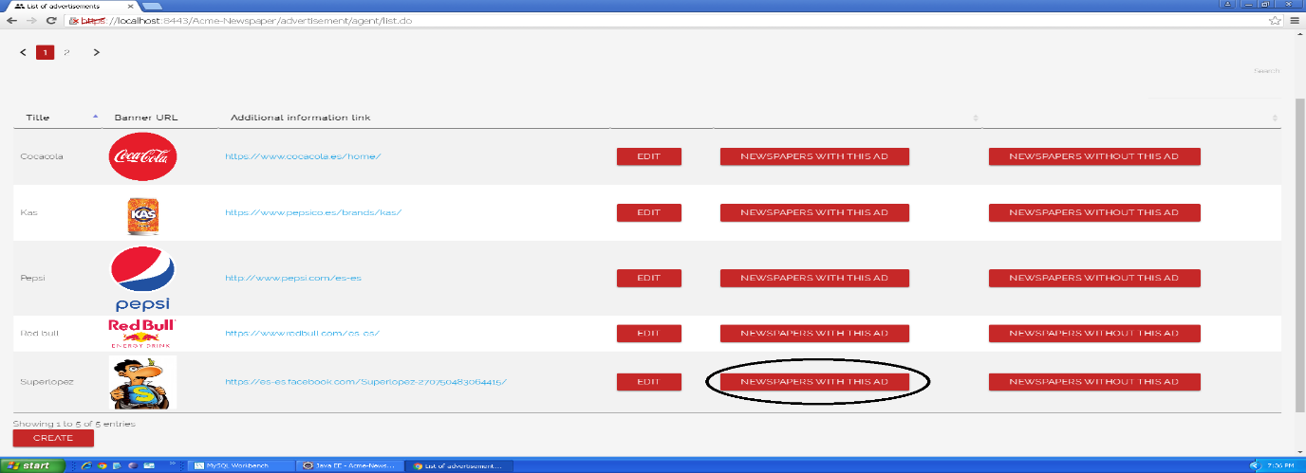

Tests

|  |  |
| --- | --- |
| **Test <#001>** | |
| **Description** | You must click “Newspapers with this ad” button in Advertisement with title “Superlopez”, once this is done, you get into the newspaper list view with the selected advertisement. |
| **Expected** | You must be redirected to the list of newspapers with the advertisement, where you can see 2 pages and 5 newspapers. |
| **Outcome** |  |
| **Notes** |  |

|  |  |
| --- | --- |
| **Test <#002>** | |
| **Description** | You must click “Newspapers with this ad” button in Advertisement with title “Superlopez”, once this is done, you get into the newspaper list view with the selected advertisement and click in the button of the second page. |
| **Expected** | You must be redirected to the second page of the list, which only has a newspaper. |
| **Outcome** |  |
| **Notes** |  |

|  |  |
| --- | --- |
| **Test <#003>** | |
| **Description** | You must click “Newspapers with this ad” button in Advertisement with title “Superlopez”, once this is done, you get into the newspaper list view with the selected advertisement and press the button to sort any of its attributes. |
| **Expected** | You must see newspapers sorted by the clicked attribute. |
| **Outcome** |  |
| **Notes** |  |

|  |  |
| --- | --- |
| **Test <#004>** | |
| **Description** | Before doing any other thing, you must set the webpage language to “Spanish”, then, you must click “Periódicos con este anuncio” button in Advertisement with title “Superlopez”, once this is done, you get into the newspaper list view with the selected advertisement. |
| **Expected** | You must be redirected to the list of newspapers with the advertisement, where you can see 2 pages and 5 newspapers. |
| **Outcome** |  |
| **Notes** |  |

|  |  |
| --- | --- |
| **Test <#005>** | |
| **Description** | Before doing any other thing, you must set the webpage language to “Spanish”, then, you must click “Periódicos con este anuncio” button in Advertisement with title “Superlopez”, once this is done, you get into the newspaper list view with the selected advertisement and click in the button of the second page. |
| **Expected** | You must be redirected to the second page of the list, which only has a newspaper. |
| **Outcome** |  |
| **Notes** |  |

|  |  |
| --- | --- |
| **Test <#006>** | |
| **Description** | Before doing any other thing, you must set the webpage language to “Spanish”, then, you must click “Periódicos con este anuncio” button in Advertisement with title “Superlopez”, once this is done, you get into the newspaper list view with the selected advertisement and press the button to sort any of its attributes. |
| **Expected** | You must see advertisements sorted by the clicked attribute. |
| **Outcome** |  |
| **Notes** |  |

# Use case 016 – List newspapers without an advertisement

Description

An unauthenticated user logs in the system as an agent, he or she goes to his or her advertisements, once there he or she lists his or her advertisements and clicks the button “Newspapers without this ad” to see the newspapers that does not contain the selected advertisement.

Access

Login > **Username:** agent1; **Password:** agent1 > Agent functions dropdown > My advertisements > “Newspapers without this ad”.

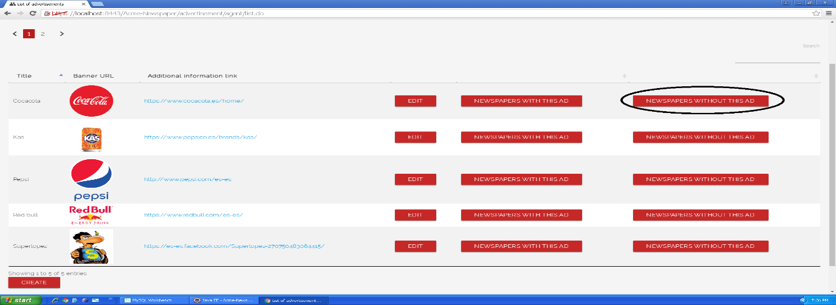

Tests

|  |  |
| --- | --- |
| **Test <#001>** | |
| **Description** | You must click “Newspapers without this ad” button in Advertisement with title “Cocacola”, once this is done, you get into the newspaper list view without the selected advertisement. |
| **Expected** | You must be redirected to the list of newspapers with the advertisement, where you can see 2 pages and 5 newspapers. |
| **Outcome** |  |
| **Notes** |  |

|  |  |
| --- | --- |
| **Test <#002>** | |
| **Description** | You must click “Newspapers without this ad” button in Advertisement with title “Cocacola”, once this is done, you get into the newspaper list view without the selected advertisement and click in the button of the second page. |
| **Expected** | You must be redirected to the second page of the list, which only has two newspapers. |
| **Outcome** |  |
| **Notes** |  |

|  |  |
| --- | --- |
| **Test <#003>** | |
| **Description** | You must click “Newspapers without this ad” button in Advertisement with title “Cocacola”, once this is done, you get into the newspaper list view without the selected advertisement and press the button to sort any of its attributes. |
| **Expected** | You must see newspapers sorted by the clicked attribute. |
| **Outcome** |  |
| **Notes** |  |

|  |  |
| --- | --- |
| **Test <#004>** | |
| **Description** | Before doing any other thing, you must set the webpage language to “Spanish”, then, you must click “Periódicos sin este anuncio” button in Advertisement with title “Cocacola”, once this is done, you get into the newspaper list view without the selected advertisement. |
| **Expected** | You must be redirected to the list of newspapers without the advertisement, where you can see 2 pages and 5 newspapers. |
| **Outcome** |  |
| **Notes** |  |

|  |  |
| --- | --- |
| **Test <#005>** | |
| **Description** | Before doing any other thing, you must set the webpage language to “Spanish”, then, you must click “Periódicos sin este anuncio” button in Advertisement with title “Cocacola”, once this is done, you get into the newspaper list view without the selected advertisement and click in the button of the second page. |
| **Expected** | You must be redirected to the second page of the list, which only has two newspapers. |
| **Outcome** |  |
| **Notes** |  |

|  |  |
| --- | --- |
| **Test <#006>** | |
| **Description** | Before doing any other thing, you must set the webpage language to “Spanish”, then, you must click “Periódicos sin este anuncio” button in Advertisement with title “Cocacola”, once this is done, you get into the newspaper list view with the selected advertisement and press the button to sort any of its attributes. |
| **Expected** | You must see newspapers sorted by the clicked attribute. |
| **Outcome** |  |
| **Notes** |  |

# Use case 017 – Remove an article

Description

An authenticated administrator goes to article list and delete an article that he or she things is unappropriated.

Access

Main menu > Search for articles

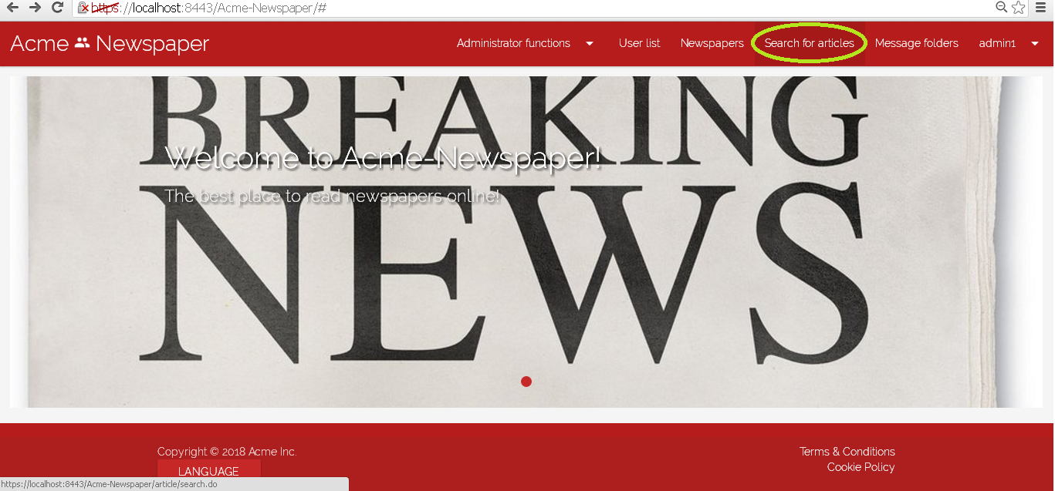

Tests

|  |  |
| --- | --- |
| **Test <#001>** | |
| **Description** | You must log in the system like “admin1” introducing in login view “admin1” like user name and “admin1” like password.    Then press in main menu the option “Search for articles”, you must be redirected to article list, now to press the button delete in the first article of the list and you will delete it. |
| **Expected** | You must be redirected to the detailed view of the newspaper called “El informático”, the article deleted belonged to that newspaper, so you can see that now this article not appear in newspaper’s article list. Also, you can go to the view “Search for articles” and prove that the article does not appear there either. |
| **Outcome** |  |
| **Notes** |  |

|  |  |
| --- | --- |
| **Test <#002>** | |
| **Description** | Now before test that use case you must set language to “Spanish”.  You must log in the system like “admin1” introducing in login view “admin1” like user name and “admin1” like password.    Then press in main menu the option “Búsqueda de artículos”, you must be redirected to article list, now to press the button delete in the first article of the list and you will delete it. |
| **Expected** | You must be redirected to the detailed view of the newspaper called “Nessie”, the article deleted belonged to that newspaper, so you can see that now this article not appear in newspaper’s article list. Also, you can go to the view “Búsqueda de artículos” and prove that the article does not appear there either. |
| **Outcome** |  |
| **Notes** |  |

# Use case 018 – Remove an unappropriated newspaper

Description

An authenticated administrator goes to newspaper list and delete a newspaper that he or she things is unappropriated. Remove a newspaper, implies removing all the articles of which it is composed.

Access

Main menu > Newspapers

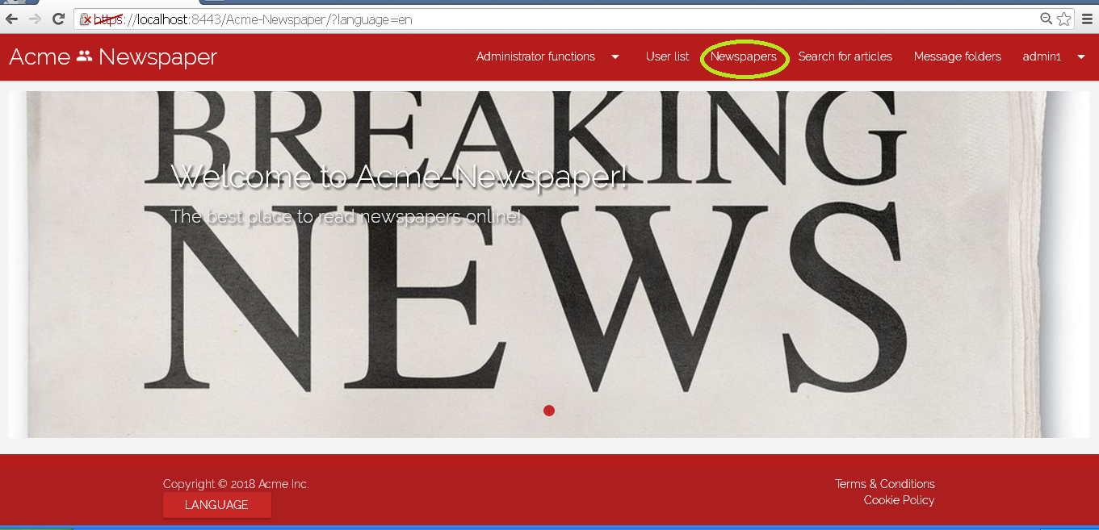

Tests

|  |  |
| --- | --- |
| **Test <#001>** | |
| **Description** | You must log in the system like “admin1” introducing in login view “admin1” like user name and “admin1” like password.    Then press in main menu the option “Newspaper”, you must be redirected to newspaper list, now to press the button delete in the second newspaper of the list, called “The big pizza”, that has only an article titled “Come hasta que no puedas mas!”, press delete button to clean it. |
| **Expected** | You must be redirected to the newspaper list view again, but like you can see the newspaper not appear. It has been deleted no the system, his articles have been deleted too, you can prove it going to “Search for articles” in the nav menu and searching for the article with the bowser tool. |
| **Outcome** |  |
| **Notes** |  |

|  |  |
| --- | --- |
| **Test <#002>** | |
| **Description** | Now before test that use case you must set language to “Spanish”.  You must log in the system like “admin1” introducing in login view “admin1” like user name and “admin1” like password.    Then press in main menu the option “Periódicos”, you must be redirected to newspaper list, now to press the button delete in the second newspaper of the list, called “The big pizza”, that has only an article titled “Come hasta que no puedas mas!”, press delete button to clean it. |
| **Expected** | You must be redirected to the newspaper list view again, but like you can see the newspaper not appear. It has been deleted no the system, his articles have been deleted too, you can prove it going to “Búsqueda de artículos” in the nav menu and searching for the article with the bowser tool. |
| **Outcome** |  |
| **Notes** |  |

# Use case 019 – Dashboard

Description

An authenticated administrator can display a dashboard with the following information:

* The average and the standard deviation of newspapers created per user.
* The average and the standard deviation of articles written by writer.
* The average and the standard deviation of articles per newspaper.
* The newspapers that have at least 10% more articles than the average.
* The newspapers that have at least 10% fewer articles than the average.
* The ratio of users who have ever created a newspaper.
* The ratio of users who have ever written an article.
* The average number of follow-ups per article.
* The average number of follow-ups per article up to one week after the corresponding newspaper’s been published.
* The average number of follow-ups per article up to two weeks after the corresponding newspaper’s been published.
* The average and the standard deviation of the number of chirps per user.
* The ratio of users who have posted above 75% the average number of chirps per user.
* The ratio of public versus private newspapers.
* The average number of articles per private newspapers.
* The average number of articles per public newspapers.
* The ratio of subscribers per private newspaper versus the total number of customers.
* The average ratio of private versus public newspapers per publisher.
* The ratio of newspapers that have at least one advertisement versus the newspapers that haven’t any.
* The ratio of advertisements that have taboo words.
* The average number of newspapers per volume.
* The ratio of subscriptions to volumes versus subscriptions to newspapers.

Access

Main menu > Administrator Functions > Dashboard

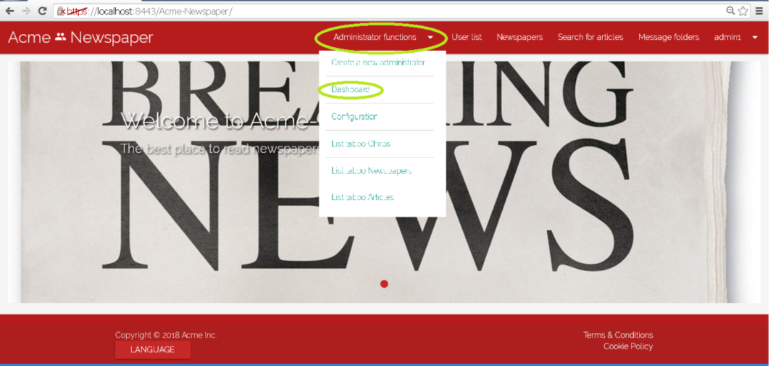

Tests

|  |  |
| --- | --- |
| **Test <#001>** | |
| **Description** | You must log in the system like “admin1” introducing in login view “admin1” like user name and “admin1” like password.    Then press in main menu the option “Administrator functions”, and in the select menu press the option “Dashboard”. |
| **Expected** | You must be redirected to Dashboard view, where you can see system statistics. |
| **Outcome** |  |
| **Notes** |  |

|  |  |
| --- | --- |
| **Test <#002>** | |
| **Description** | Now before test that use case you must set language to “Spanish”.  You must log in the system like “admin1” introducing in login view “admin1” like user name and “admin1” like password.    Then press in main menu the option “Funciones de administrador”, and in the select menu press the option “Dashboard”. |
| **Expected** | You must be redirected to Dashboard view, where you can see system statistics. |
| **Outcome** |  |
| **Notes** |  |

# Use case 020 – Manage a list of taboo words

Description

An authenticated administrator can manage a list of taboo words to the system.

Access

Main menu > Administrator Functions > Configuration

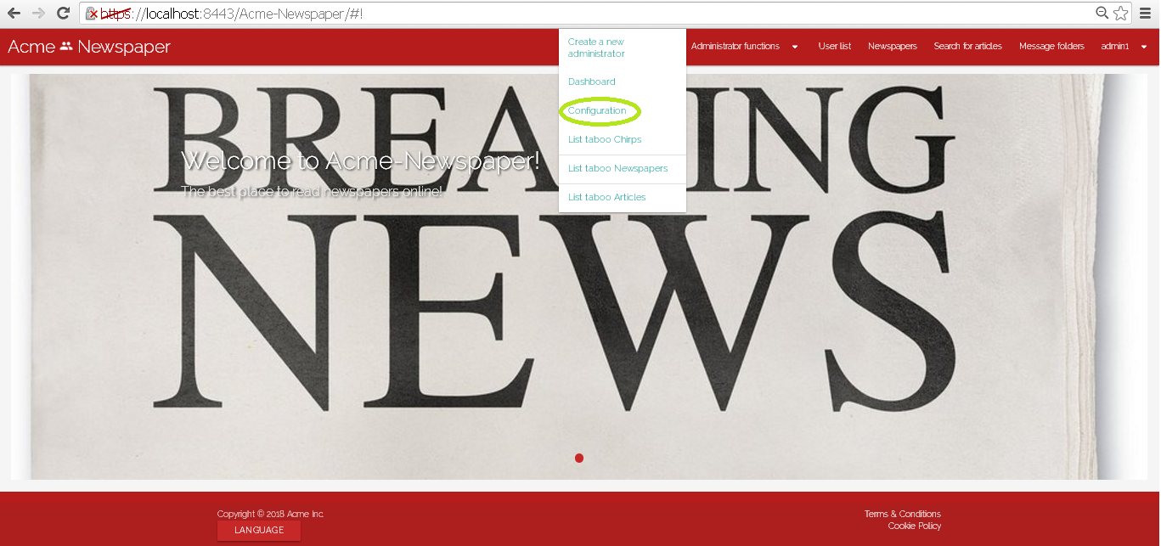

Tests

|  |  |
| --- | --- |
| **Test <#001>** | |
| **Description** | You must log in the system like “admin1” introducing in login view “admin1” like user name and “admin1” like password.    Then press in main menu the option “Administrator functions”, and in the select menu press the option “Configuration”. The you will see a view with the actual configuration, press “edit”.    Now you will be redirected to a form view where you can edit taboo words, when try to change or add some taboo word and they will be update pressing the button “save”. |
| **Expected** | You must be redirected to Configuration view, with the new taboo words saved. |
| **Outcome** |  |
| **Notes** |  |
| **Test <#002>** | |
| **Description** | Now before test that use case you must set language to “Spanish”.  You must log in the system like “admin1” introducing in login view “admin1” like user name and “admin1” like password.    Then press in main menu the option “Funciones de administrador”, and in the select menu press the option “Configuración”. The you will see a view with the actual configuration, press “editar”.    Now you will be redirected to a form view where you can edit taboo words, when try to change or add some taboo word and they will be update pressing the button “guardar”. |
| **Expected** | You must be redirected to Configuration view, with the new taboo words saved. |
| **Outcome** |  |
| **Notes** |  |

# Use case 021 – List the articles that contain taboo words

Description

An authenticated administrator can list articles that contain taboo words.

Access

Main menu > Administrator Functions > List Taboo Articles

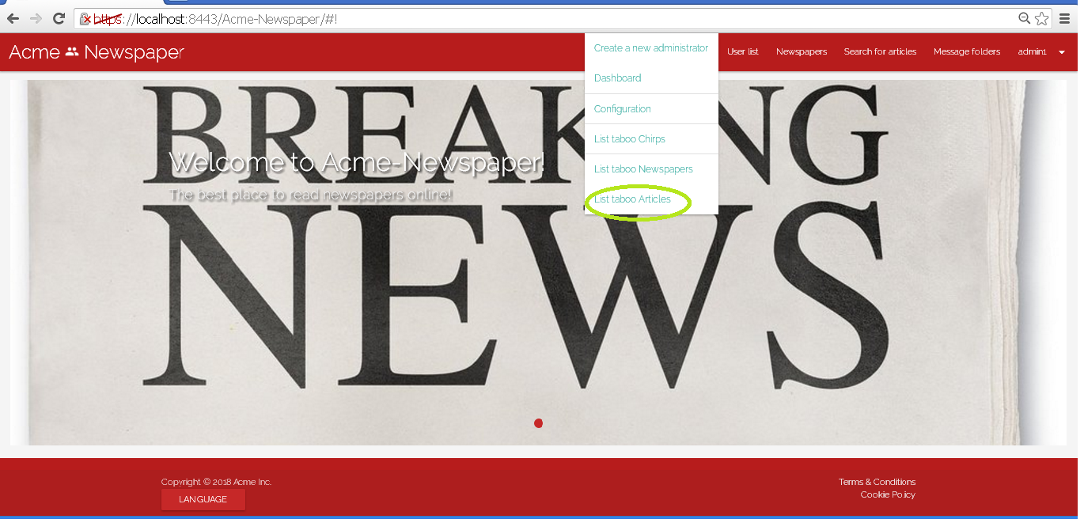

Tests

|  |  |
| --- | --- |
| **Test <#001>** | |
| **Description** | You must log in the system like “admin1” introducing in login view “admin1” like user name and “admin1” like password.    Then press in main menu the option “Administrator functions”, and in the select menu press the option “List taboo articles”. |
| **Expected** | You must be redirected to taboo article list. |
| **Outcome** |  |
| **Notes** |  |

|  |  |
| --- | --- |
| **Test <#002>** | |
| **Description** | Now before test that use case you must set language to “Spanish”.  You must log in the system like “admin1” introducing in login view “admin1” like user name and “admin1” like password.    Then press in main menu the option “Funciones de administrador”, and in the select menu press the option “Listar Artículos tabú”. |
| **Expected** | You must be redirected to taboo article list. |
| **Outcome** |  |
| **Notes** |  |

# Use case 023 – List the newspapers that contain taboo words

Description

An authenticated administrator can list newspapers that contain taboo words.

Access

Main menu > Administrator Functions > List taboo Newspapers

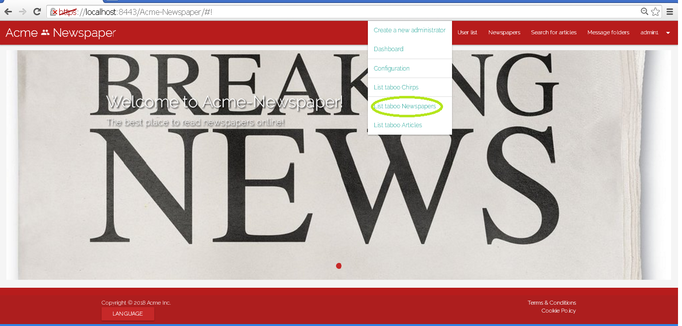

Tests

|  |  |
| --- | --- |
| **Test <#001>** | |
| **Description** | You must log in the system like “admin1” introducing in login view “admin1” like user name and “admin1” like password.    Then press in main menu the option “Administrator functions”, and in the select menu press the option “List taboo newspapers”. |
| **Expected** | You must be redirected to taboo newspaper list. |
| **Outcome** |  |
| **Notes** |  |

|  |  |
| --- | --- |
| **Test <#002>** | |
| **Description** | Now before test that use case you must set language to “Spanish”.  You must log in the system like “admin1” introducing in login view “admin1” like user name and “admin1” like password.    Then press in main menu the option “Funciones de administrador”, and in the select menu press the option “Listar Periódicos tabú”. |
| **Expected** | You must be redirected to taboo newspaper list. |
| **Outcome** |  |
| **Notes** |  |

# Use case 024 – List advertisements containing taboo words in its title

Description

An authenticated administrator can list the advertisements that contain taboo words in its title.

Access

Main menu > Administrator Functions > List taboo advertisements

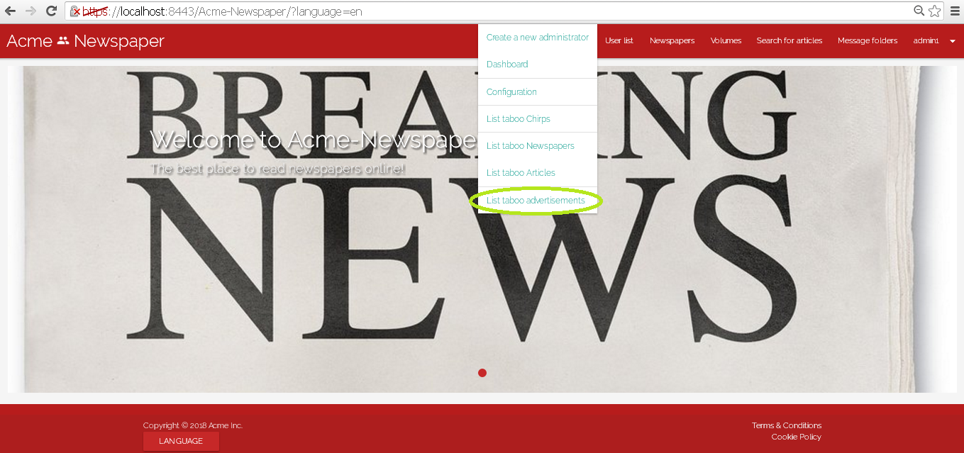

Tests

|  |  |
| --- | --- |
| **Test <#001>** | |
| **Description** | You must log in the system like “admin1” introducing in login view “admin1” like user name and “admin1” like password.    Then press in main menu the option “Administrator functions”, and in the select menu press the option “List taboo advertisements”. |
| **Expected** | You must be redirected to taboo advertisement list. |
| **Outcome** |  |
| **Notes** |  |

|  |  |
| --- | --- |
| **Test <#002>** | |
| **Description** | Now before test that use case you must set language to “Spanish”.  You must log in the system like “admin1” introducing in login view “admin1” like user name and “admin1” like password.    Then press in main menu the option “Funciones de administrador”, and in the select menu press the option “Listar anuncios tabú”. |
| **Expected** | You must be redirected to taboo advertisement list. |
| **Outcome** |  |
| **Notes** |  |

# Use case 025 – Remove an unappropriated advertisement

Description

An authenticated administrator goes to advertisement list and delete an advertisement that he or she things is unappropriated.

Access

Main menu > Advertisement

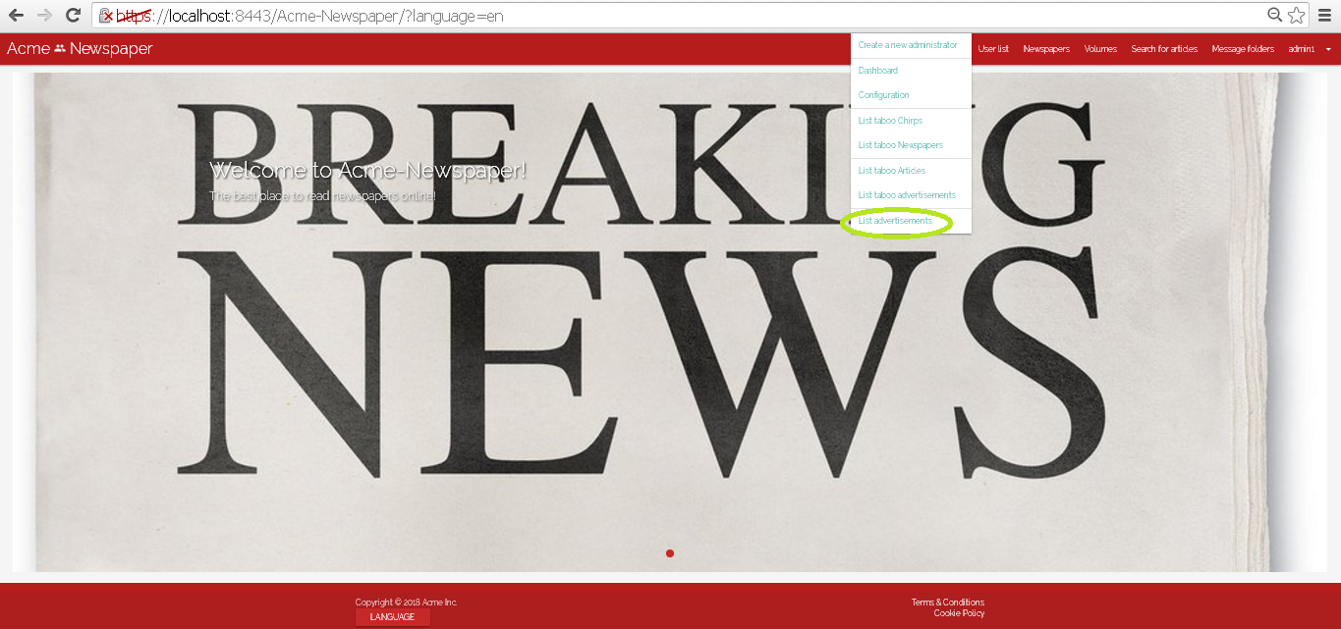

Tests

|  |  |
| --- | --- |
| **Test <#001>** | |
| **Description** | You must log in the system like “admin1” introducing in login view “admin1” like user name and “admin1” like password.    Then press in main menu “Administrator functions/List advertisement” you must be redirected to advertisement list, now to press the button delete in the first advertisement of the list and you will be deleted it. |
| **Expected** | You must be redirected to Taboo advertisement list, that is other view when you can delete advertisement in the same way. |
| **Outcome** |  |
| **Notes** |  |

|  |  |
| --- | --- |
| **Test <#002>** | |
| **Description** | Now before test that use case you must set language to “Spanish”.  You must log in the system like “admin1” introducing in login view “admin1” like user name and “admin1” like password.    Then press in main menu “Funciones de Administrador /Lista de anuncios” you must be redirected to advertisement list, now to press the button “borrar” in the first advertisement of the list and you will be deleted it. |
| **Expected** | You must be redirected to Taboo advertisement list, that is other view when you can delete advertisement in the same way. |
| **Outcome** |  |
| **Notes** |  |

# Use case 026 – Broadcast a message to the actors of the system

Description

An authenticated administrator broadcast a message to the actors of the system.

Access

Main menu > Message Folder

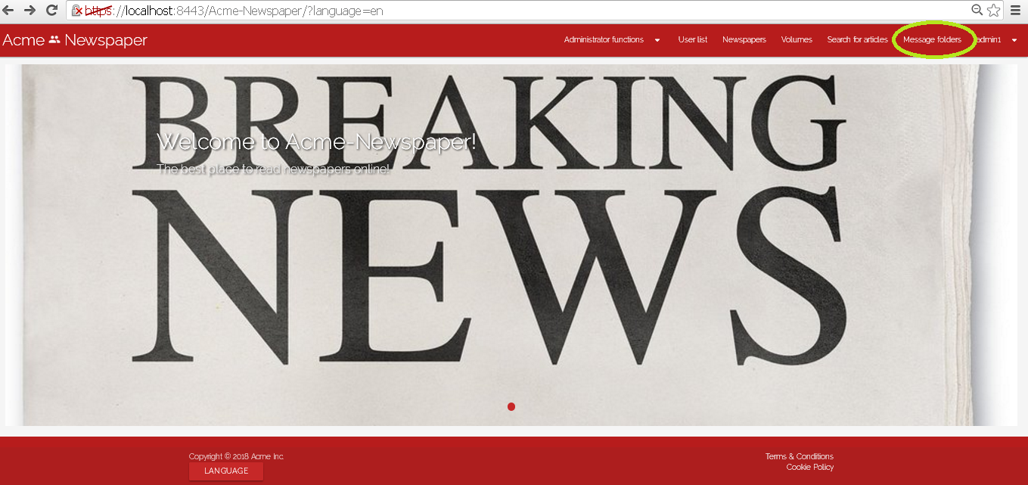

Tests

|  |  |
| --- | --- |
| **Test <#002>** | |
| **Description** | You must log in the system like “admin1” introducing in login view “admin1” like user name and “admin1” like password.    Then press in main menu the option “Message Folder” and select “SEND A MESSAGE”    Now, fill the form with the same parameters (priority select: “HIGH”; subject: “Standard message for everybody”; body: “That is a standard message for every actor in the system”; and check “Broadcast”). When the form is full filled, press save button and it will be broadcast to every actor in the system. |
| **Expected** | You must be redirected to outbox folder. You also test that use case login in the system with some actor and you will have the message in the inbox folder of this actor. |
| **Outcome** |  |
| **Notes** |  |

|  |  |
| --- | --- |
| **Test <#002>** | |
| **Description** | Now before test that use case you must set language to “Spanish”.  You must log in the system like “admin1” introducing in login view “admin1” like user name and “admin1” like password.    Then press in main menu the option “Carpeta de Mensajes” and select “ENVIAR NUEVO MENSAJE”    Now, fill the form with the same parameters (priority select: “HIGH”; Asunto: “Standard message for everybody” ;Cuerpo: “That is a standard message for every actor in the system”; and check “Emision”). When the form is full filled, press save button and it will be broadcast to every actor in the system. |
| **Expected** | You must be redirected to outbox folder. You also test that use case login in the system with some actor and you will have the message in the inbox folder of this actor. |
| **Outcome** |  |
| **Notes** |  |

# Use case 027 – Remove an unappropriated chirp

Description

An authenticated administrator removes a chirp that he or she thinks its unappropriated.

Access

Main menu > User List > Display User

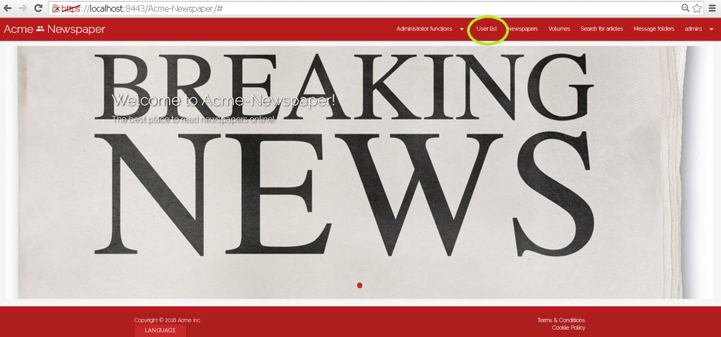

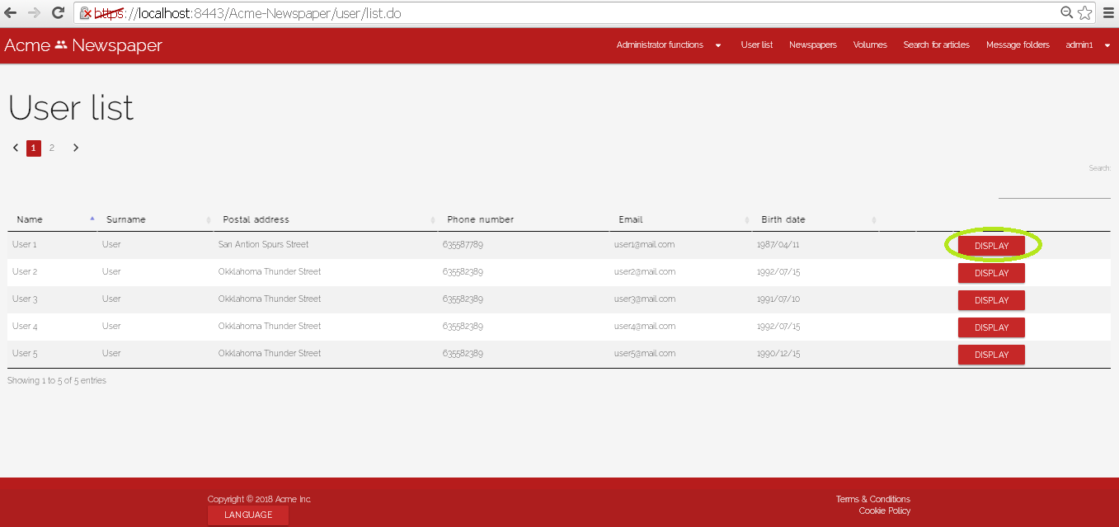

Tests

|  |  |
| --- | --- |
| **Test <#001>** | |
| **Description** | You must log in the system like “admin1” introducing in login view “admin1” like user name and “admin1” like password.    Go to “User List” and press display in the first user, now you must be redirected to the profile of that user, go a little down and you will see the created chirps list of the user selected, press delete in the first one and you will be deleted it. |
| **Expected** | At the end of the use case you must be redirected to the taboo chirp list. |
| **Outcome** |  |
| **Notes** |  |

|  |  |
| --- | --- |
| **Test <#002>** | |
| **Description** | Now before test that use case you must set language to “Spanish”.  You must log in the system like “admin1” introducing in login view “admin1” like user name and “admin1” like password.    Go to “User List” and press display in the first user, now you must be redirected to the profile of that user, go a little down and you will see the created chirps list of the user selected, press delete in the first one and you will be deleted it. |
| **Expected** | At the end of the use case you must be redirected to the taboo chirp list. |
| **Outcome** |  |
| **Notes** |  |

# Use case 028 – List the chirps that contain taboo words

Description

An authenticated administrator can list chirps that contain taboo words.

Access

Main menu > Administrator Functions > List taboo Chirps

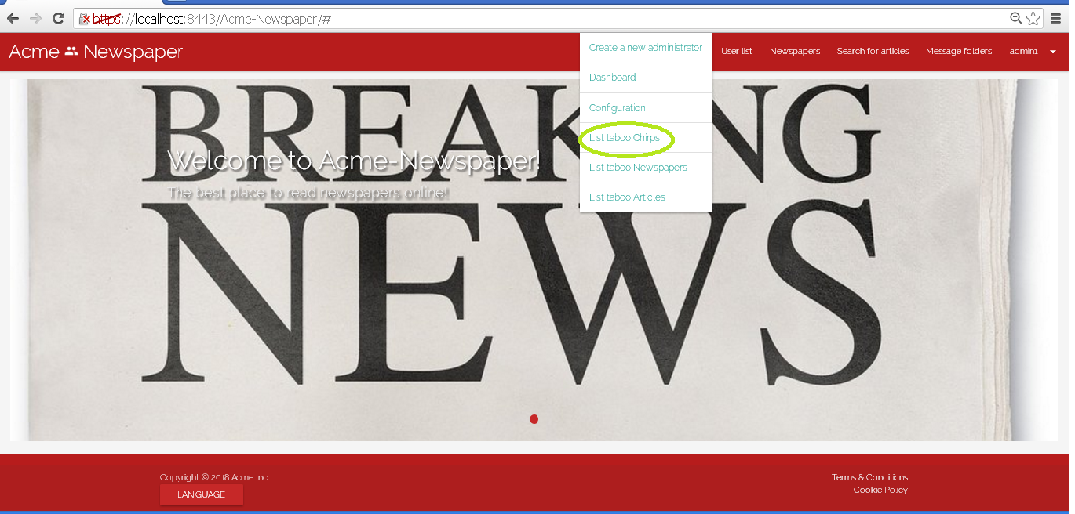

Tests

|  |  |
| --- | --- |
| **Test <#001>** | |
| **Description** | You must log in the system like “admin1” introducing in login view “admin1” like user name and “admin1” like password.    Then press in main menu the option “Administrator functions”, and in the select menu press the option “List taboo chirps”. |
| **Expected** | You must be redirected to taboo chirps list. |
| **Outcome** |  |
| **Notes** |  |

|  |  |
| --- | --- |
| **Test <#002>** | |
| **Description** | Now before test that use case you must set language to “Spanish”.  You must log in the system like “admin1” introducing in login view “admin1” like user name and “admin1” like password.    Then press in main menu the option “Funciones de administrador”, and in the select menu press the option “Listar Chirps tabú”. |
| **Expected** | You must be redirected to taboo chirps list. |
| **Outcome** |  |
| **Notes** |  |

# Use case 029 – Not authenticated list volumes and its newspapers

Description

An actor who is not authenticated list the volumes in the system and browse their newspapers as long as they are authorized (for instance, a private newspaper cannot be fully displayed to unauthenticated actors).

Access

Main menu > Volumes

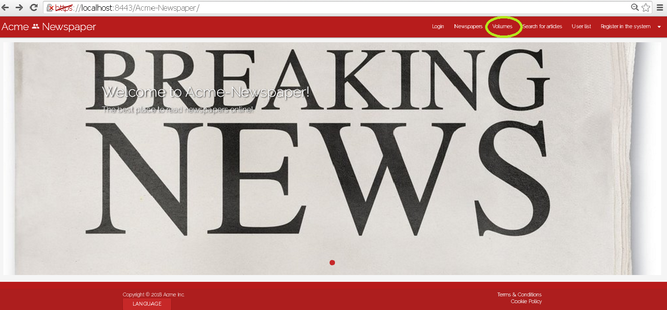

Tests

|  |  |
| --- | --- |
| **Test <#001>** | |
| **Description** | Go to “Volumes” in main menu and you will be redirected to volumes list. Press “display” in the first one, and you will see the detailed view of a volume, with its newspapers .    Note that you can see public and not public newspapers, the differences are that in not public newspaper you can dislay it but not its articles. |
| **Expected** | You must be redirected to detailed view of a volume. |
| **Outcome** |  |
| **Notes** |  |

|  |  |
| --- | --- |
| **Test <#002>** | |
| **Description** | Go to “Volúmenes” in main menu and you will be redirected to volumes list. Press “mostrar” in the first one, and you will see the detailed view of a volume, with its newspapers .    Note that you can see public and not public newspapers, the differences are that in not public newspaper you can dislay it but not its articles. |
| **Expected** | You must be redirected to detailed view of a volume. |
| **Outcome** |  |
| **Notes** |  |

# Use case 030 – Send message

Description

An unauthenticated user logs in the system as admin, he or she goes to his or her message folders, once there he or she clicks on send a message, fulfil the message and sent it.

Access

Login > **Username:** admin1; **Password:** admin1 > Message folders > “Send a message” button.

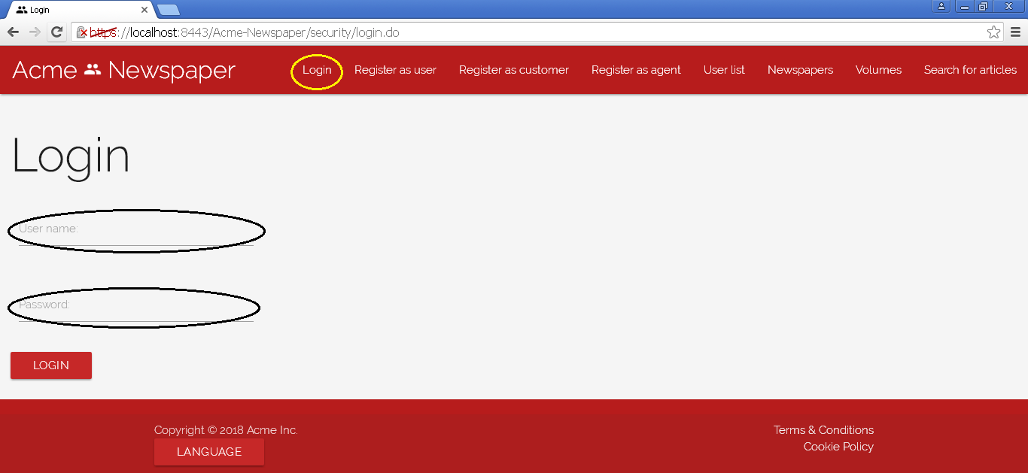

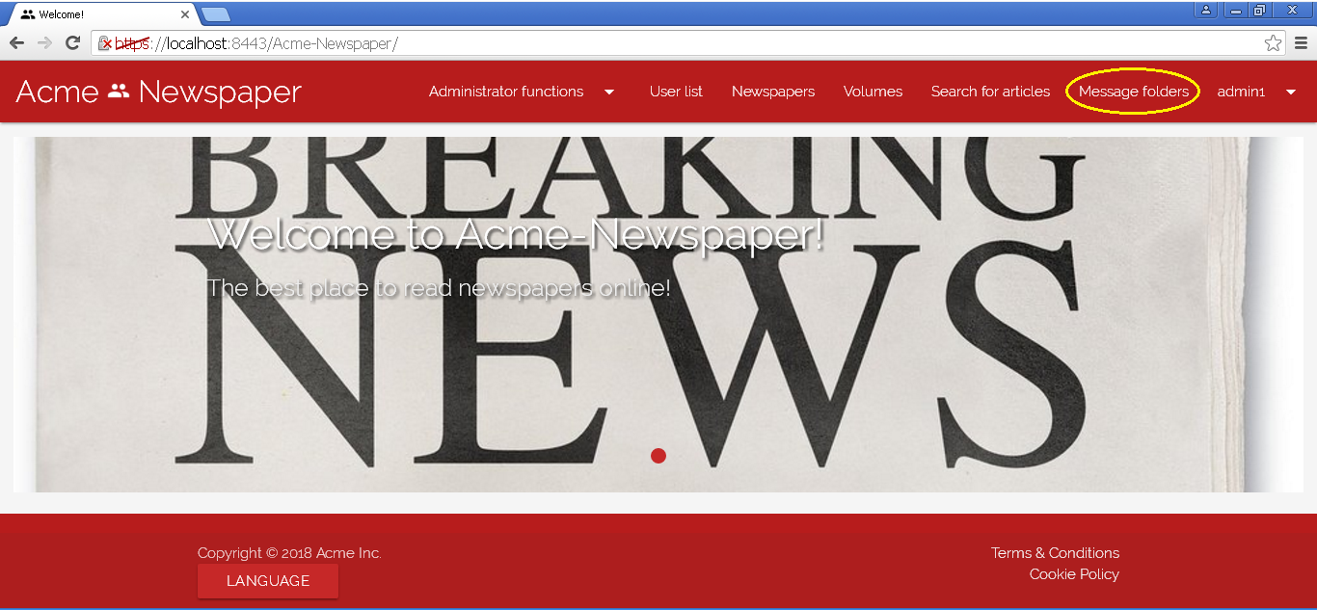

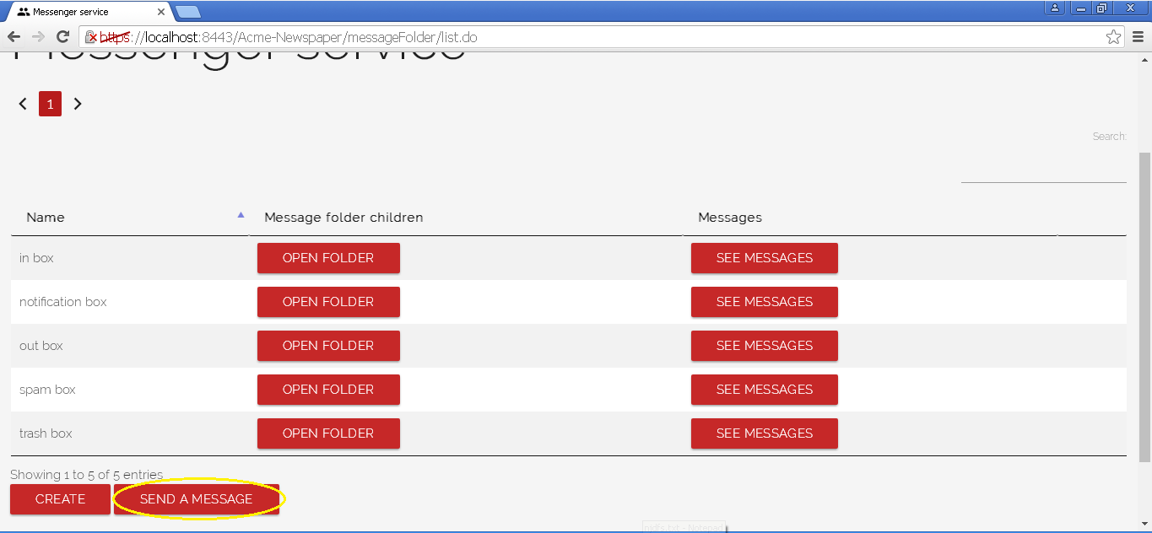

Tests

|  |  |
| --- | --- |
| **Test <#001>** | |
| **Description** | Once you are in the send message view, you press the cancel button. |
| **Expected** | The system must redirect you to the message folders list. |
| **Outcome** |  |
| **Notes** |  |

|  |  |
| --- | --- |
| **Test <#002>** | |
| **Description** | Once you are in the send message view, you press the save button without data in any field. |
| **Expected** | The system must redirect you to the same view (send message) but showing validation messages in fields. |
| **Outcome** |  |
| **Notes** |  |

|  |  |
| --- | --- |
| **Test <#003>** | |
| **Description** | Once you are in the send message view, you press the save button inserting the following data: **Priority:** NEUTRAL**, Subject: “**<script>alarm('Hacked!'); </script>”, **Body:** “This is a test”, **Send to:** “user1@mail.com”**,** and the broadcast **unchecked.** |
| **Expected** | The system must redirect you to the same view (send message) but showing “Insecure HTML” validation error. |
| **Outcome** |  |
| **Notes** |  |

|  |  |
| --- | --- |
| **Test <#004>** | |
| **Description** | Once you are in the send message view, you press the save button inserting the following data: **Priority:** NEUTRAL**, Subject:** “Favourite quote!”, **Body:** “No gods or kings, only the man.”, **Send to:** “user1@mail.com”**,** and the **Broadcast** unchecked. |
| **Expected** | The system must redirect you to the out box messages list. |
| **Outcome** |  |
| **Notes** |  |

|  |  |
| --- | --- |
| **Test <#005>** | |
| **Description** | Once you are in the out box, you press the “move” button of the message sent previously, change the message folder to spam box. |
| **Expected** | The system must redirect you to the spam box messages list. |
| **Outcome** |  |
| **Notes** |  |

|  |  |
| --- | --- |
| **Test <#006>** | |
| **Description** | Once you are in the spam box, you press the delete button of the message sent previously. |
| **Expected** | The system must redirect you to the same view but without the message (moved to trash box). |
| **Outcome** |  |
| **Notes** |  |

|  |  |
| --- | --- |
| **Test <#007>** | |
| **Description** | Once you are in the trash box, you press the delete button of the message deleted previously. |
| **Expected** | The system must redirect you to the same view but without the message deleted definitely. |
| **Outcome** |  |
| **Notes** |  |

|  |  |
| --- | --- |
| **Test <#008>** | |
| **Description** | Once you are in the send message view, you press the save button inserting the following data: **Priority:** NEUTRAL**, Subject:** “Favourite quote!”, **Body:** “No gods or kings, only the man.”and the **Broadcast** checkbox checked. |
| **Expected** | The system must redirect you to the out box messages list and the administrator must have the message in notification box. |
| **Outcome** |  |
| **Notes** |  |

|  |  |
| --- | --- |
| **Test <#009>** | |
| **Description** | Before doing any other thing, you must set the webpage language to “Spanish”, then, once you are in the send message view, you press the “Cancelar” button. |
| **Expected** | The system must redirect you to the message folders view. |
| **Outcome** |  |
| **Notes** |  |

|  |  |
| --- | --- |
| **Test <#010>** | |
| **Description** | Before doing any other thing, you must set the webpage language to “Spanish”, then, once you are in the send message view, you press the “Enviar” button without data in any field. |
| **Expected** | The system must redirect you to the same view (send message) but showing validation messages in fields. |
| **Outcome** |  |
| **Notes** |  |

|  |  |
| --- | --- |
| **Test <#011>** | |
| **Description** | Before doing any other thing, you must set the webpage language to “Spanish”, then, once you are in the create article view, you press the “Guardar” button inserting the following data: **Prioridad:** NEUTRAL**, Asunto: “**<script>alarm('Hacked!'); </script>”, **Cuerpo del mensaje:** “This is a test”, **Enviado a:** “user1@mail.com”**,** and the **Emisión** unchecked**.** |
| **Expected** | The system must redirect you to the same view (send message) but showing “HTML inseguro” validation error. |
| **Outcome** |  |
| **Notes** |  |

|  |  |
| --- | --- |
| **Test <#012>** | |
| **Description** | Before doing any other thing, you must set the webpage language to “Spanish”, then, once you are in the create article view, you press the “Guardar” button inserting the following data: **Prioridad:** NEUTRAL**, Asunto:** “Favourite quote!”, **Cuerpo del mensaje:** “No gods or kings, only the man.”, **Send to:** “user1@mail.com”**,** and the **Emisión** unchecked. |
| **Expected** | The system must redirect you to the out box messages list. |
| **Outcome** |  |
| **Notes** |  |

|  |  |
| --- | --- |
| **Test <#013>** | |
| **Description** | Before doing any other thing, you must set the webpage language to “Spanish”, then, once you are in the out box, you press the “Mover” button of the message sended previously, change the message folder to spam box. |
| **Expected** | The system must redirect you to the spam box messages list. |
| **Outcome** |  |
| **Notes** |  |

|  |  |
| --- | --- |
| **Test <#014>** | |
| **Description** | Before doing any other thing, you must set the webpage language to “Spanish”, then, once you are in the spam box, you press the “borrar” button of the message sended previously. |
| **Expected** | The system must redirect you to the same view but without the message (moved to trash box). |
| **Outcome** |  |
| **Notes** |  |

|  |  |
| --- | --- |
| **Test <#015>** | |
| **Description** | Before doing any other thing, you must set the webpage language to “Spanish”, then, once you are in the trash box, you press the “borrar” button of the message deleted previously. |
| **Expected** | The system must redirect you to the same view but without the message deleted definitely. |
| **Outcome** |  |
| **Notes** |  |

|  |  |
| --- | --- |
| **Test <#016>** | |
| **Description** | Before doing any other thing, you must set the webpage language to “Spanish”, then, once you are in the send message view, you press the save button inserting the following data: **Prioridad:** NEUTRAL**, Asunto:** “Favourite quote!”, **Cuerpo del mensaje:** “No gods or kings, only the man.”, **Enviado a:** “user1@mail.com”**,** and the **Emisión** checked. |
| **Expected** | The system must redirect you to the out box messages list and the administrator must have the message in notification box. |
| **Outcome** |  |
| **Notes** |  |

# Use case 031 – Register as a customer

Description

An unauthenticated goes to the register view and fills the form, once the form is filled, he or she presses the register as customer button.

Access

Main Menu > Register as customer.

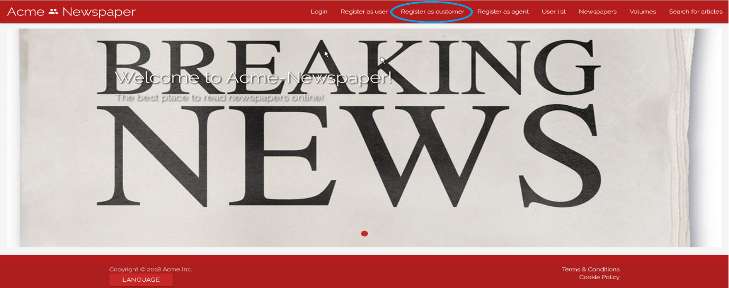

Tests

|  |  |
| --- | --- |
| **Test <#001>** | |
| **Description** | The form must be filled in with the following data: **Name:** ‘Juan’; **Surname:** ’David Pérez’; **Phone number:** ‘650353637’; **Postal address:** ‘123 Walk Street, USA’; **Email:** ’[juanda@gmail.com](mailto:juanda@gmail.com)’; **Birthdate:** ’16/04/1996’ **Username:** ‘juanda’; **Password:** ‘davidjuan’; **Confirm password:** ‘davidjuan’. You must also accept **Terms & Conditions**. |
| **Expected** | At the end of the use case, the system must redirect you to the main view. |
| **Outcome** |  |
| **Notes** |  |

|  |  |
| --- | --- |
| **Test <#002>** | |
| **Description** | The form must be blank, only check the “I accept Terms & Conditions” box, otherwise the “Register” button will be inaccessible. |
| **Expected** | At the end of the use case, the system must redirect you to the same form to register a customer, but each field must have its validation error. |
| **Outcome** |  |
| **Notes** |  |

|  |  |
| --- | --- |
| **Test <#003>** | |
| **Description** | Once you access the form, you must press the “Cancel” button. |
| **Expected** | You must be redirected to main view. |
| **Outcome** |  |
| **Notes** | In this test, fields content can be both filled or blank. |

|  |  |
| --- | --- |
| **Test <#004>** | |
| **Description** | The form must be filled in with the following data: **Name:** ‘Juan’; **Surname:** ’David Pérez’; **Phone number:** ‘650353637’; **Postal address:** ‘<script>alarm('Hacked!'); </script>’; **Email:** ’[juanda@gmail.com](mailto:juanda@gmail.com)’; **Birthdate:** ’16/04/1996’ **Username:** ‘juanda’; **Password:** ‘davidjuan’; **Confirm password:** ‘davidjuan’. You must also accept **Terms & Conditions**. |
| **Expected** | At the end of the use case, the system must redirect you to the register customer form with an error message in “Postal Address” field where you can read “Insecure HTML” |
| **Outcome** |  |
| **Notes** |  |

|  |  |
| --- | --- |
| **Test <#005>** | |
| **Description** | Before accessing the form, language must be set to “Spanish”, after this, the form must be filled in with the following data: **Name:** ‘Juan’; **Surname:** ’David Pérez’; **Phone number:** ‘650353637’; **Postal address:** ‘123 Walk Street, USA’; **Email:** ’[juanda@gmail.com](mailto:juanda@gmail.com)’; **Birthdate:** ’16/04/1996’ **Username:** ‘juanda’; **Password:** ‘davidjuan’; **Confirm password:** ‘davidjuan’. You must also accept **Terms & Conditions** |
| **Expected** | At the end of the use case, the system must redirect you to the main view. |
| **Outcome** |  |
| **Notes** |  |

|  |  |
| --- | --- |
| **Test <#006>** | |
| **Description** | Before accessing the form, language must be set to “Spanish”, after this, the form must be blank, only the “Acepto los términos y condiciones” box must be checked, otherwise the “Registrarse” button will be inaccessible. |
| **Expected** | At the end of the use case, the system must redirect you to the same form, but each field must have its validation error. |
| **Outcome** |  |
| **Notes** |  |

|  |  |
| --- | --- |
| **Test <#007>** | |
| **Description** | Before accessing the form, language must be set to “Spanish”, after this, once you access the form, you must press the “Cancelar” button. |
| **Expected** | You must be redirected to main view. |
| **Outcome** |  |
| **Notes** | In this test field content can be both filled or blank. |

|  |  |
| --- | --- |
| **Test <#008>** | |
| **Description** | Before accessing the form, language must be set to “Spanish”, after this, the form must be filled in with the following data: **Nombre:** ‘<script>alarm('Hacked!'); </script>’; **Apellidos:** ’Delgado García’; **Número de teléfono:** ‘650879554’; **Dirección:** ‘123 Walk Street, USA’; **Correo electrónico:** ’[josedega@us.es](mailto:josedega@us.es)’; **Fecha de nacimiento:** ’16/04/1996’ **Nombre de usuario:** ‘josedega’; **Contraseña:** ‘josedega’; **Confirmación de contraseña:** ‘josedega’. You must also accept **Términos y Condiciones**. |
| **Expected** | At the end of the use case, the system must redirect you to the register user form with an error message in “Nombre” field where you can read “HTML inseguro” |
| **Outcome** |  |
| **Notes** |  |

# Use case 032 – Subscribe newspapers as customer with credit card

Description

Subscribe to a private newspaper as a customer.

Access

Go to Login and Authenticate as Customer with the following data: Username: “customer1”, Password: “customer1”. Then go to Newspaper list and click the “The Big Hamburger” Details button.

Finally select subscribe button.

Main menu > Login > Newspaper List > Newspaper Details > Subscribe

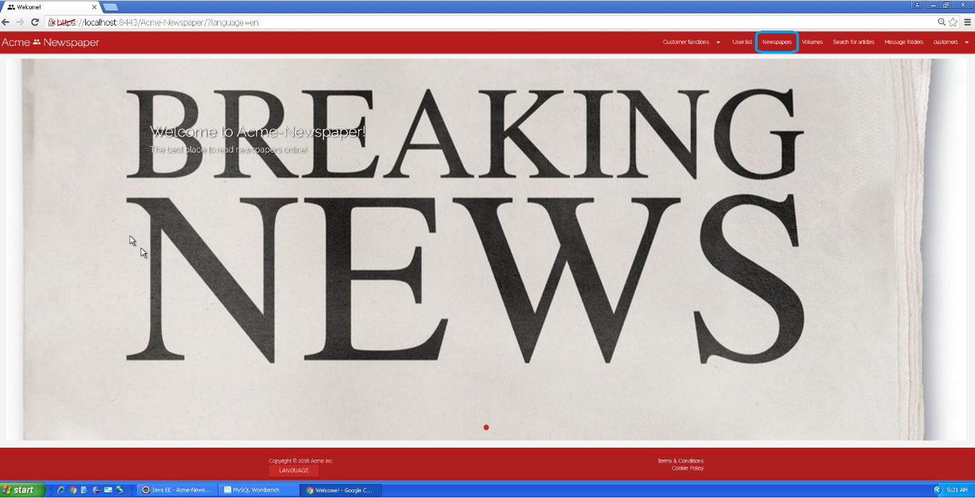

Tests

|  |  |
| --- | --- |
| **Test <#001>** | |
| **Description** | The subscribe form must be filled with the following data:  **Holder Name:** ‘John Strip’, **Brand Name:** ‘MasterCard’,  **Number:** ‘4711674499519753’, **Expiration month:** ‘10’, **Expiration year:** ‘20’, **CCV:** ‘990’.  Then click on Customer functions > Subscribed newspaper |
| **Expected** | You must see “The Big Hamburger” in the list. |
| **Outcome** |  |
| **Notes** |  |

|  |  |
| --- | --- |
| **Test <#002>** | |
| **Description** | After the first test successful, then, go to the List of newspaper again, but this time click on “Details” button of “The big pizza”, and click on “Subscribe”.  Click on “Use this card”, and “Save”.  Then click on “Customer functions” > “Subscribed newspapers” |
| **Expected** | You must see “The big pizza” and “The big hamburger” in the list. |
| **Outcome** |  |
| **Notes** |  |

|  |  |
| --- | --- |
| **Test <#003>** | |
| **Description** | Once “Details” button is pressed, fill or left fields in blank and click “Cancel” button. |
| **Expected** | You must be redirected to newspaper list. |
| **Outcome** |  |
| **Notes** |  |

|  |  |
| --- | --- |
| **Test <#004>** | |
| **Description** | The form must be blank |
| **Expected** | At the end of the use case, the system must redirect you to the same form, but each field must have its validation error. |
| **Outcome** |  |
| **Notes** |  |

|  |  |
| --- | --- |
| **Test <#005>** | |
| **Description** | The subscribe form must be filled with the following data:  **Holder Name:** ‘John Strip’, **Brand Name:** ‘<script>alarm('Hacked!'); </script>’,  **Number:** ‘4711674499519753’, **Expiration month:** ‘10’, **Expiration year:** ‘20’, **CCV:** ‘990’. |
| **Expected** | At the end of the use case, the system must redirect you to the same form with an error message in “Brand Name” field where you can read “Insecure HTML” |
| **Outcome** |  |
| **Notes** |  |

|  |  |
| --- | --- |
| **Test <#006>** | |
| **Description** | Before accessing newspapers, you must select Spanish language.  The subscribe form must be filled with the following data:  **Nombre del portador:** ‘John Strip’, **Nombre de la marca:** ‘MasterCard’,  **Número:** ‘4711674499519753’, **Mes de caducidad:** ‘10’, **Año de caducidad:** ‘20’, **CCV:** ‘990’.  Then click on “Funciones de cliente” > “Periódicos a los que estoy suscrito” |
| **Expected** | You must see “The Big Hamburger” in the list. |
| **Outcome** |  |
| **Notes** |  |

|  |  |
| --- | --- |
| **Test <#007>** | |
| **Description** | Before accessing newspapers, you must select Spanish language.  After the first test successful, then, go to the List of newspaper again, but this time click on “Detalles” button of “The big pizza”, and click on “Suscribirse”.  Click on “Usar esta tarjeta”, and “Guardar”.  Then click on “Funciones de cliente” > “Periódicos a los que estoy suscrito”. |
| **Expected** | You must see “The big pizza” and “The big hamburger” in the list. |
| **Outcome** |  |

|  |  |
| --- | --- |
| **Test <#008>** | |
| **Description** | Before accessing newspapers, you must select Spanish language.  Once “Detalles” button is pressed, fill or left fields in blank and click “Cancelar” button. |
| **Expected** | You must be redirected to newspaper list |
| **Outcome** |  |
| **Notes** |  |

|  |  |
| --- | --- |
| **Test <#009>** | |
| **Description** | Before accessing newspapers, you must select Spanish language.  The form must be blank. |
| **Expected** | At the end of the use case, the system must redirect you to the same form, but each field must have its validation error. |
| **Outcome** |  |
| **Notes** |  |

|  |  |
| --- | --- |
| **Test <#010>** | |
| **Description** | Before accessing newspapers, you must select Spanish language.  The subscribe form must be filled with the following data:  **Nombre del portador:** ‘John Strip’, **Nombre de la marca:** ‘<script>alarm('Hacked!'); </script>’,  **Número:** ‘4711674499519753’, **Mes de caducidad:** ‘10’, **Año de caducidad:** ‘20’, **CCV:** ‘990’. |
| **Expected** | At the end of the use case, the system must redirect you to the same form with an error message in “Brand Name” field where you can read “Insecure HTML” |
| **Outcome** |  |
| **Notes** |  |

# Use case 033 – Change owns newspaper to public or private

Description

Change own newspaper to public or private as User.

Access

Go to Login and Authenticate as User with the following data: Username: “user1”, Password: “user1”. Then go to “User functions” -> “My newspapers not published”, and click the “Edit” button from the first entry.

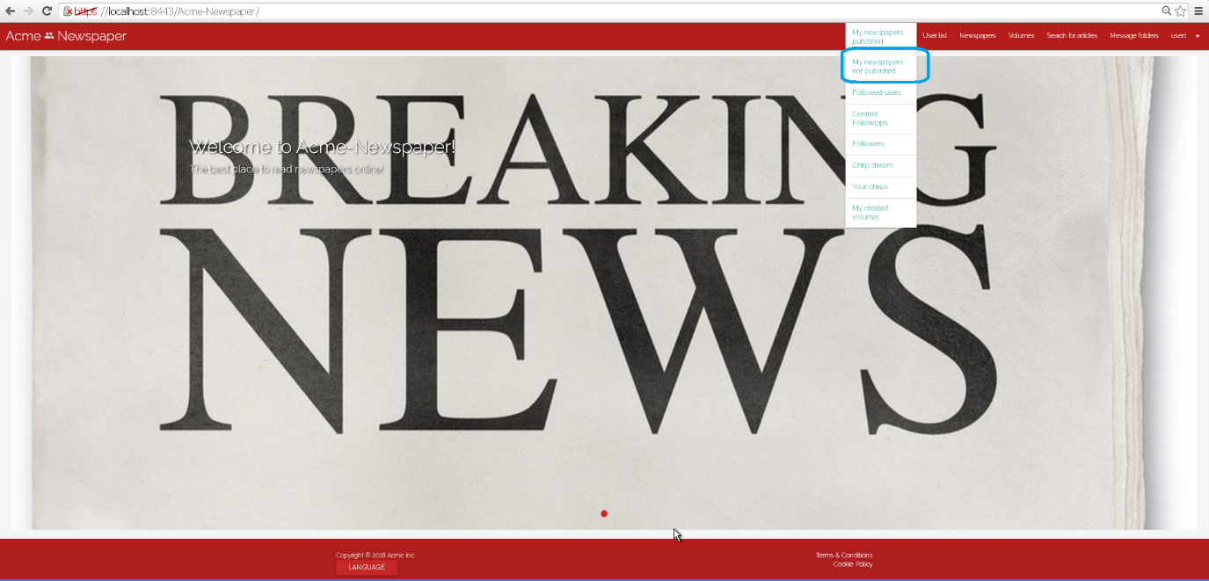

Tests

|  |  |
| --- | --- |
| **Test <#001>** | |
| **Description** | Uncheck the “Public” button and save. |
| **Expected** | You must be redirected to your not published newspapers list, and newspaper must not be public. |
| **Outcome** |  |
| **Notes** |  |

|  |  |
| --- | --- |
| **Test <#002>** | |
| **Description** | After the first test complete, go again to edit form but this time check the “Public” button and save. |
| **Expected** | You must be redirected to your not published newspapers list, and newspaper must be public. |
| **Outcome** |  |
| **Notes** |  |

|  |  |
| --- | --- |
| **Test <#003>** | |
| **Description** | Click on the cancel button of the edit form. |
| **Expected** | You must be redirected to your not published newspapers list. |
| **Outcome** |  |
| **Notes** |  |

|  |  |
| --- | --- |
| **Test <#004>** | |
| **Description** | Uncheck the “Public” button and save. |
| **Expected** | Before accessing list of your newspapers, you must select Spanish language.  You must be redirected to your not published newspapers list, and newspaper must not be public. |
| **Outcome** |  |
| **Notes** |  |

|  |  |
| --- | --- |
| **Test <#005>** | |
| **Description** | After the fourth test complete:  Go again to edit form but this time check the “Public” button and save. |
| **Expected** | You must be redirected to your not published newspapers list, and newspaper must be public. |
| **Outcome** |  |
| **Notes** |  |

|  |  |
| --- | --- |
| **Test <#006>** | |
| **Description** | Before accessing list of your newspapers, you must select Spanish language.  After that, go to the specified edit form.  Click on the cancel button of the edit form. |
| **Expected** | You must be redirected to your not published newspapers list. |
| **Outcome** |  |
| **Notes** |  |

# Use case 034 – Subscribe volume as customer with credit card

Description

Subscribe to volume as a customer.

Access

Go to Login and Authenticate as Customer with the following data: Username: “customer1”, Password: “customer1”. Then go to Volumes list, and click the “Test Volume 1” Display button .

Finally select subscribe button.

Main menu > Login > Volumes > Display > Subscribe

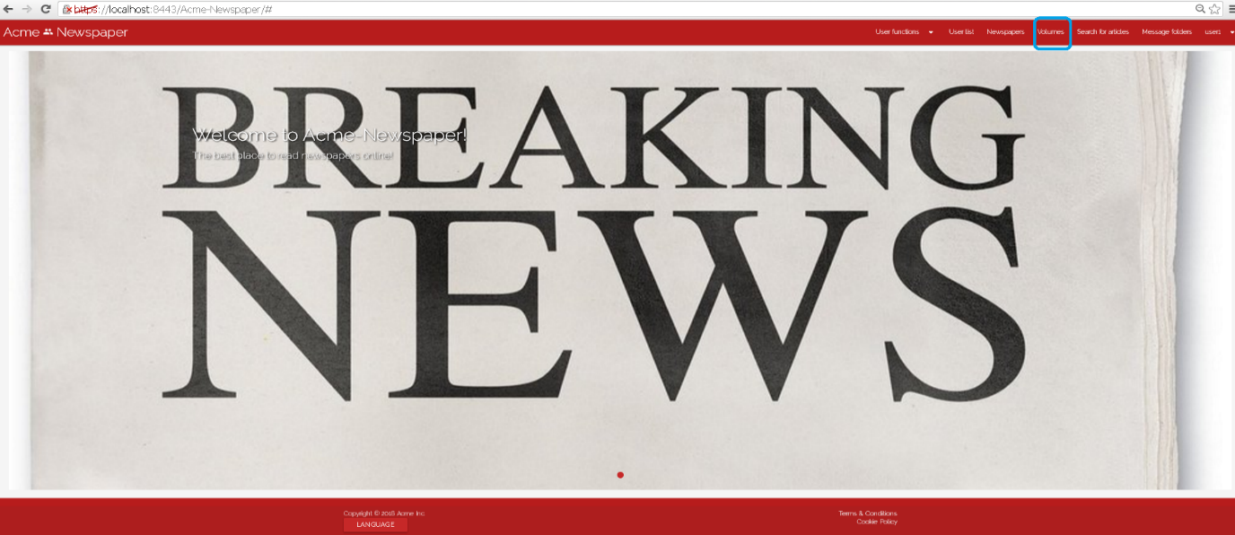

Tests

|  |  |
| --- | --- |
| **Test <#001>** | |
| **Description** | The subscribe form must be filled with the following data:  **Holder Name:** ‘John Strip’, **Brand Name:** ‘MasterCard’,  **Number:** ‘4711674499519753’, **Expiration month:** ‘10’, **Expiration year:** ‘20’, **CCV:** ‘990’.  Then click on Customer functions > My subscribed volumes |
| **Expected** | You must see “Test Volume 1” in the list. |
| **Outcome** |  |
| **Notes** |  |

|  |  |
| --- | --- |
| **Test <#002>** | |
| **Description** | After the first test successful, then, go to the List of volumes again, but this time click on “Display” button of “Test volume 2”, and click on “Subscribe”.  Click on “Use this card”, and “Save”.  Then click on “Customer functions” > “Subscribed volumes” |
| **Expected** | You must see “Test Volume 1” and “Test Volume 2” in the list. |
| **Outcome** |  |
| **Notes** |  |

|  |  |
| --- | --- |
| **Test <#003>** | |
| **Description** | Once “Display” button is pressed, fill or left fields in blank and click “Cancel” button. |
| **Expected** | You must be redirected to volumes list |
| **Outcome** |  |
| **Notes** |  |

|  |  |
| --- | --- |
| **Test <#004>** | |
| **Description** | The form must be blank |
| **Expected** | At the end of the use case, the system must redirect you to the same form, but each field must have its validation error. |
| **Outcome** |  |
| **Notes** |  |

|  |  |
| --- | --- |
| **Test <#005>** | |
| **Description** | The subscribe form must be filled with the following data:  **Holder Name:** ‘John Strip’, **Brand Name:** ‘<script>alarm('Hacked!'); </script>’,  **Number:** ‘4711674499519753’, **Expiration month:** ‘10’, **Expiration year:** ‘20’, **CCV:** ‘990’. |
| **Expected** | At the end of the use case, the system must redirect you to the same form with an error message in “Brand Name” field where you can read “Insecure HTML” |
| **Outcome** |  |
| **Notes** |  |

|  |  |
| --- | --- |
| **Test <#006>** | |
| **Description** | Before accessing newspapers, you must select Spanish language.  The subscribe form must be filled with the following data:  **Nombre del portador:** ‘John Strip’, **Nombre de la marca:** ‘MasterCard’,  **Número:** ‘4711674499519753’, **Mes de caducidad:** ‘10’, **Año de caducidad:** ‘20’, **CCV:** ‘990’.  Then click on “Funciones de cliente” > “Mis volúmenes suscritos” |
| **Expected** | You must see “Test Volume 1” in the list. |
| **Outcome** |  |
| **Notes** |  |

|  |  |
| --- | --- |
| **Test <#007>** | |
| **Description** | Before accessing newspapers, you must select Spanish language.  After the first test successful, then, go to the List of newspaper again, but this time click on “Mostar” button of “The big pizza”, and click on “Suscribirse”.  Click on “Usar esta tarjeta”, and “Guardar”.  Then click on “Funciones de cliente” > “Mis volúmenes suscritos”. |
| **Expected** | You must see “The big pizza” and “The big hamburger” in the list. |
| **Outcome** |  |

|  |  |
| --- | --- |
| **Test <#008>** | |
| **Description** | Before accessing newspapers, you must select Spanish language.  Once “Mostar” button is pressed, fill or left fields in blank and click “Cancelar” button. |
| **Expected** | You must be redirected to volumes list. |
| **Outcome** |  |
| **Notes** |  |

|  |  |
| --- | --- |
| **Test <#009>** | |
| **Description** | Before accessing newspapers, you must select Spanish language.  The form must be blank. |
| **Expected** | At the end of the use case, the system must redirect you to the same form, but each field must have its validation error. |
| **Outcome** |  |
| **Notes** |  |

|  |  |
| --- | --- |
| **Test <#010>** | |
| **Description** | Before accessing volumes, you must select Spanish language.  The subscribe form must be filled with the following data:  **Nombre del portador:** ‘John Strip’, **Nombre de la marca:** ‘<script>alarm('Hacked!'); </script>’,  **Número:** ‘4711674499519753’, **Mes de caducidad:** ‘10’, **Año de caducidad:** ‘20’, **CCV:** ‘990’. |
| **Expected** | At the end of the use case, the system must redirect you to the same form with an error message in “Brand Name” field where you can read “Insecure HTML” |
| **Outcome** |  |
| **Notes** |  |

# Use case 035 – Create new volumes as user

Description

Create new volume with newspapers, authenticated as user in the system.

Access

Go to Login and Authenticate as User with the following data: Username: “user1”, Password: “user1”. Then go to Volumes list, and click the “Create” button .

Main menu > Login > Volume List > Create

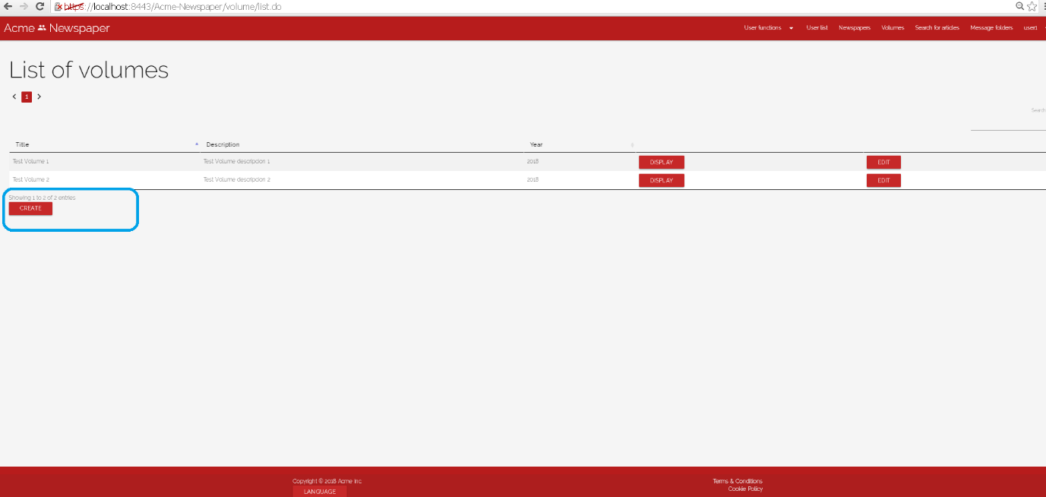

Tests

|  |  |
| --- | --- |
| **Test <#001>** | |
| **Description** | The create form must be filled with the following data:  **Title:** ‘Best volume’, **Description:** ‘News compilation’,  **Newspapers: “El informático”, “The big pizza”.**  Then click on User functions > My created volumes |
| **Expected** | You must be redirected to “Best volume” details view. |
| **Outcome** |  |
| **Notes** |  |

|  |  |
| --- | --- |
| **Test <#002>** | |
| **Description** | The create form must be filled with the following data:  **Title:** ‘’, **Description:** ‘’,  **Newspapers: “El informático”, “The big pizza”.** |
| **Expected** | You must be redirected to the same form, but parameters errors must be shown. |
| **Outcome** |  |
| **Notes** |  |

|  |  |
| --- | --- |
| **Test <#003>** | |
| **Description** | Before accessing newspapers, you must select Spanish language.  The create form must be filled with the following data:  **Titulo:** ‘Best volume’, **Descripción:** ‘News compilation’,  **Periódicos: “El informático”, “The big pizza”.**    Then click on Funciones de usuario > Mis volúmenes creados |
| **Expected** | You must be redirected to “Best volume” details view. |
| **Outcome** |  |
| **Notes** |  |

|  |  |
| --- | --- |
| **Test <#004>** | |
| **Description** | The create form must be filled with the following data:  **Title:** ‘’, **Description:** ‘’,  **Newspapers: “El informático”, “The big pizza”.** |
| **Expected** | You must be redirected to the same form, but parameters errors must be shown. |
| **Outcome** |  |

# Use case 036 – Create a follow up

Description

A user creates a follow Up in one of the article that he or she has created.

Access

Main menu > Newspapers

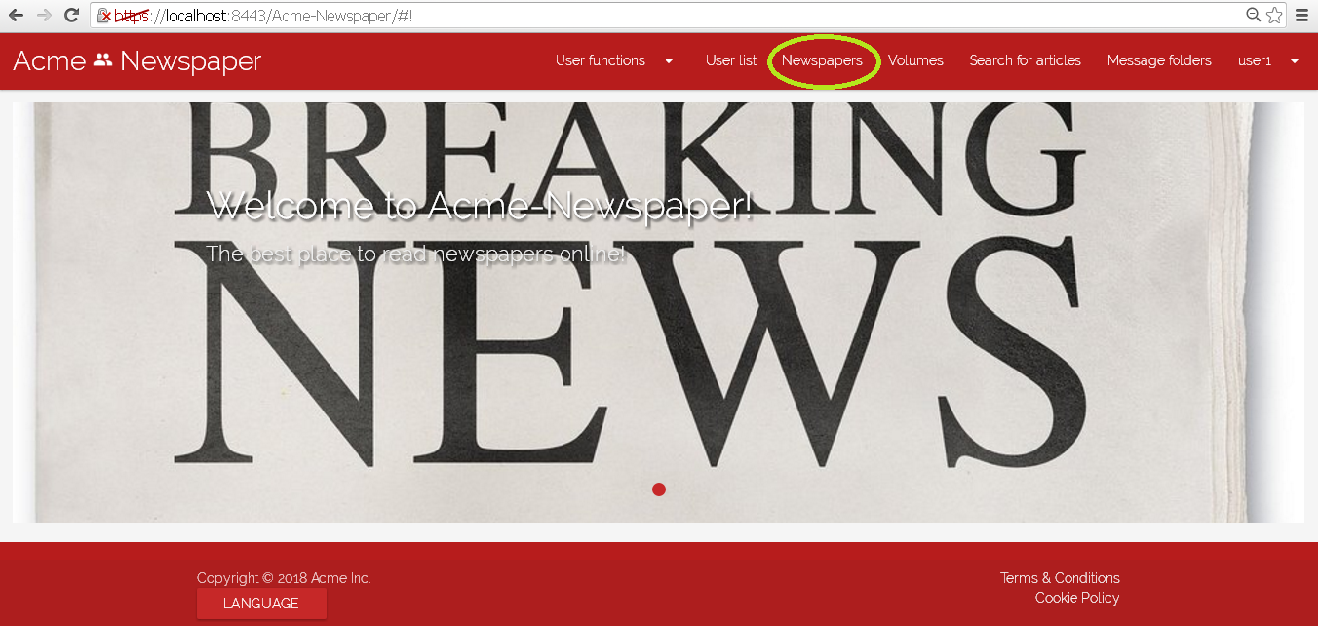

Tests

|  |  |
| --- | --- |
| **Test <#001>** | |
| **Description** | You must be login as “user1” with the password “user1”, then press Newspapers in main menu, now select “details” in newspaper called “El Informático”.    Once in the detailed newspaper view click the title of the article “5 consejos para perder peso corriendo”    go to its follow-Ups and press button “create”.    Fill the form with “new” in all the fields like the picture and then press the button “save”. |
| **Expected** | You must be redirected to the detailed view of the article “5 consejos para perder peso corriendo”, where you can see the new follow-Up created. |
| **Outcome** |  |
| **Notes** |  |

|  |  |
| --- | --- |
| **Test <#002>** | |
| **Description** | Put now language into “Spanish”, and we are going to repeat process in test 1; First at all log like “user1”, with “user1” like password, then go to “periódicos” and press “mostrar” in “El Informático”,    and display the article “5 consejos para perder peso”,    and its follow-Ups press “crear” button. Now fill the form with “new” in all the fields like test 1 and press “Guardar”. |
| **Expected** | You must be redirected to the detailed view of the article “5 consejos para perder peso corriendo”, where you can see the new follow-Up created. |
| **Outcome** |  |
| **Notes** |  |

# Use case 037 – List created follow ups

Description

A user lists his or her created follow-ups.

Access

Main menu > User functions > Created FollowUps

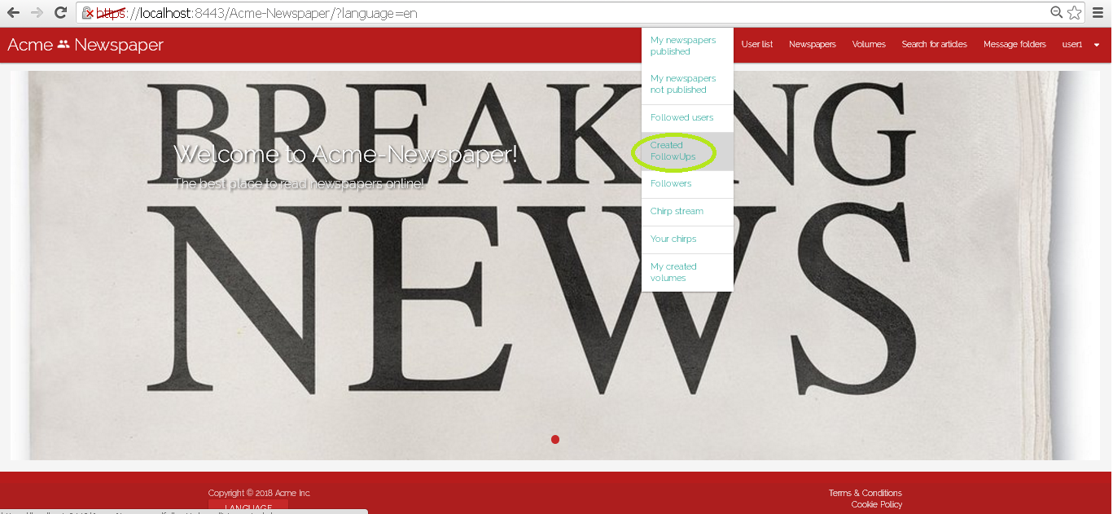

Tests

|  |  |
| --- | --- |
| **Test <#001>** | |
| **Description** | You must log in the system like “user1” with the password “user1” too. Now press User Functions > Created FollowUps. |
| **Expected** | You must be redirected to a view with follow-ups created by user1. |
| **Outcome** |  |
| **Notes** |  |

|  |  |
| --- | --- |
| **Test <#002>** | |
| **Description** | You must log in the system like “user1” with the password “user1” too. Now press Funciones de Usuario > FollowUps creados . |
| **Expected** | You must be redirected to a view with follow-ups created by user1. |
| **Outcome** |  |
| **Notes** |  |

# Additional tests

|  |  |
| --- | --- |
| **Test <#001>** | |
| **Description** | **Accept Cookie Policy**: to do that you must enter in the system for the first time. And you will get the button to accept in the main view. Also, you can open a private window in the browser to get this button. |
| **Expected** | The system save that you accept cookie policy and this option never reappears. |
| **Outcome** |  |
| **Notes** | Note that once you accept cookies, this button will never appear again. |

